**TEXT DETECTION AND RECOGNITION USING**

**DEEP LEARNING**

A project report submitted in partial fulfillment of the requirements for the award of the degree of

Bachelor of Technology in Computer Science and Engineering



by

G. Lokeswari CH.V.L. Prasanna

17JG1A0547 17JG1A0521

A. Kusuma J. Uma Sree

17JG1A0506 17JG1A0553



Department of Computer Science and Engineering

**Gayatri Vidya Parishad College of Engineering for Women**

(Affiliated to Jawaharlal Nehru Technological University, Kakinada)

2017-21

**Gayatri Vidya Parishad College of Engineering for Women**

Department of Computer Science and Engineering



### **CERTIFICATE**

This is to certify that the project report titled **Text Detection And Recognition Using Deep Learning** is a bonafide work of following IV/IV B.Tech students in the Department of Computer Science and Engineering, Gayatri Vidya Parishad College of Engineering for Women affiliated to JNT University, Kakinada during the academic year 2019-20, in partial fulfillment of the requirement for the award of the degree of Bachelor of Technology of this university.

Ms G. Lokeswari Ms Ch.V.L Prassana

Ms A. Kusuma Ms J. Uma Sree

Internal Guide Head of the Department

External Examiner

**ACKNOWLEDGEMENT**

We take the opportunity to one and all who have helped in making the project possible. We are thankful to **Gayatri Vidya Parishad College of Engineering for Women,** for giving us the opportunity to work on a project as part of the curriculum.

Our sincere thanks to our guide **Ms. K. Suneetha**, Assistant Professor in Department of Computer Science and Engineering for her simulating guidance and assistance from the beginning of the project.

We are very much thankful to our Head of Computer Science Engineering **Prof.P.V.S.L. Jagadamba**. Head of the Department for her help and encouragement and also for providing the lab facility to complete the project work.

Our sincere thanks to our beloved Vice-Principal **Prof. G. Sudheer** for providing the best faculty and lab facility throughout these academic years.

Our sincere thanks to our beloved principal **Prof. K. Subba Rao** for providing the best faculty and lab facility throughout these academic years.

Our sincere thanks to our beloved Director **Prof. Dr. E. V. Prasad** for providing the best faculty and lab facility throughout these academic years.

Finally we are thankful to our entire faculty and our lab technicians for their good wishes and constructive criticism, which led to the successful completion of the project.

**CONTENTS**

**TOPICS** **PAGE NO**

Abstract i

List of Screens ii

List of figures iii

List of Tables iv

1. **INTRODUCTION 1 - 3**
   1. Motivation of the Project 1

1.2 Problem definition 2

1.3 Objective of the Project 2

1.4 Limitations of the Project 2

1.5 Organization of the Project 3

**2. LITERATURE SURVEY 4 - 29**

* 1. Introduction 4

2.1.1 Importance of Text Detection and Recognition 5

2.1.2 Text Detection 6

2.1.3 Text Recognition 8

2.1.4 EAST (Efficient and Accurate Scene Text) Detector 10

2.1.5 Text Recognition Using Tesseract OCR Pipe line 15

2.1.6 Non-Maximum Suppression 18

* + 1. Fully Convolutional Network 21

2.2 Existing System 27 2.2.1 Disadvantages of Existing System 28

2.3 Proposed System 28

* 1. Conclusion 29

**3. ANALYSIS 30 - 33**

3.1 Introduction 30

3.2 Software Requirement Specification 30

3.2.1 User requirement 31

3.2.2 Software requirement 32

3.2.3 Hardware requirement 32

3.3 Flowchart of the code 33

3.4 Conclusion 33

**4. DESIGN 34 - 44**

4.1 Introduction 34

4.2 Basic Building blocks of UML 36

4.2.1 UML diagrams 37

4.2.1.1 Class diagram 37

4.2.1.2 Use case diagram 40

4.2.1.3 Sequence diagram 42

4.2.1.4 State chart diagram 43

4.3 Conclusion 44

**5. IMPLEMENTATION AND RESULT 45 - 74**

5.1 Introduction 45

5.1.1 Python Installations 45

5.1.2 Tesseract Software Installations 49

5.2 Software Design 59

5.2.1 Front End 59

5.2.2 Back End 59

5.3 Sample Code 60

5.4 Output Screens 70

5.5 Conclusion 74

**6. TESTING & VALIDATION 75 - 80**

6.1 Introduction

6.1.1 Scope 75

6.1.2 Defects And Failures 75

6.1.3 Compatibility 76

6.1.4 Input Combinations And Preconditions 76

6.1.5 Static vs. Dynamic Testing 76

6.1.6 Software Verification and Validation 77

6.2 Design of test cases and scenarios 77

6.3 Validation Testing 78

6.4 Conclusion 80

**7. CONCLUSION 81**

**8. REFERENCES 82**

**ABSTRACT**

Image text detection and recognition have received increasing attention in computer vision due to its potential applications in numerous fields. Previous approaches for text detection have already achieved promising performances across various benchmarks. However, they usually fall short when dealing with challenging scenarios, because the overall performance is determined by the interplay of multiple stages and components in the pipelines. In this project we use a fast and accurate scene text detection pipeline that has only two stages. The pipeline utilizes a fully convolutional network (FCN) model that directly produces word or text-line level predictions, excluding redundant and slow intermediate steps. The produced text predictions, which can be either rotated rectangles or quadrangles, are sent to Non-Maximum Suppression to yield final results. The located target regions are taken into consideration and then recognize the words in these regions. Compared with existing methods, the proposed algorithm achieves significantly enhanced performance, while running much faster, according to the qualitative and quantitative experiments on standard benchmark.

**LIST OF SCREENS**

|  |  |  |
| --- | --- | --- |
| **S. No** | **Screen No.** | **Screen PageNo** |

1. Screen1 Python Installer For Windows 46

2. Screen2 Installation Of Python 47

3. Screen3 Python Setup was Successful 48

4. Screen4 Python Successfully Completed 49

5. Screen5 Tesseract software 51

6. Screen6 Tesseract software Installation for windows 53

7. Screen7 Destination folder for Tesseract software 53

8. Screen8 Setting up the destination folder for Tesseract 54

9. Screen9 Tesseract software Installed 55

10. Screen10 Test Image1 for Tesseract Software 56

11. Screen11 Test Image2 for Tesseract Software 57

12. Screen12 Test Image3 for Tesseract Software 58

13. Screen13 User Interface 70

14. Screen14 Taking Input Image From Device 71

15. Screen15 Input Image is Displayed on User Interface 71

16 Screen16 Select Notepad to Store Recognized Text 72

17 Screen17 Text in the Input Image is Stored in the Notepad 72

18 Screen18 Output Image with Detected Text 73

19 Screen19 Taking video as a Input from Device 73

20 Screen20 Select Notepad to store recognized text 74

21 Screen21 Video is displayed as output with detected text74

**List OF Figures**

**s.no Figure no Figure page no**

1 fig1 comparison of pipelines of several recent 7

works on scene text detection

2 fig2 Describing modules in semantic based text

Recognition 9

3 fig3 Structure of our text detection FCN with PVAnet 10

4 fig4 Structure of our text detection FCN with VGG 13

5 fig5 VGG16 Architecture 14

6 fig6 Example of Non-Maximum Supression 21

7 fig7 Classification 21

8 fig8 All layers are convolutional layers 23

9 fig9 upsampling at the last step 24

10 fig10 Feature map/filter number along layers 24

11 fig11 upsampling via Deconvolution 25

12 fig12 Comparison with different FCNS 26

13 fig13 Visualized results compared 27

14 fig14 Flow chart diagram 33

15 fig15 class diagram 38

16 fig16 usecase diagram 42

17 fig17 Sequence diagram 43

18 fig18 state chart diagram 44

**LIST OF TABLES**

|  |  |  |  |
| --- | --- | --- | --- |
| **S. No** | **Table No.** | **Table Name** | **Page No.** |
| 1 | Table 1 | Output Geometry Design | 12 |
| 2 | Table 2 | White Box Testing | 78 |

**1. INTRODUCTION**

**1.1 MOTIVATION OF THE PROJECT**

In the running world, there is growing demand for the software systems to recognize characters in computer system when information is scanned through paper documents as we know that we have number of newspapers and books which are in printed format related to different subjects. These days there is a huge demand in “storing the information available in these paper documents in to a computer storage disk and then later reusing this information by searching process”. One simple way to store information in these paper documents in to computer system is to first scan the documents and then store them as Images. But to reuse this information it is very difficult to read the individual contents and searching the contents form these documents line-by-line and word-by-word. The reason for this difficulty is the font characteristics of the characters in paper documents are different to font of the characters in computer system. As a result, computer is unable to recognize the characters while reading them. This concept of storing the contents of paper documents in computer storage place and then reading and searching the content is called document processing. Sometimes in this document processing we need to process the information that is related to languages other than the English in the world. For this document processing we need a software system called Character Recognition System. This process is also called Document Image Analysis (DIA). Thus our need is to develop character recognition software system to perform Document Image Analysis which transforms documents in paper format to electronic format. For this process there are various techniques in the world. Among all those techniques we have chosen Optical Character Recognition as main fundamental technique to recognize characters. The conversion of paper documents in to electronic format is an on-going task in many of the organizations particularly in Research and Development (R&D) area, in large business enterprises, in government institutions, so on. From our problem statement we can introduce the necessity of Optical Character Recognition in mobile electronic devices such as cell phones, digital cameras to acquire images and recognize them as a part 2 of face recognition and validation. To effectively use Optical Character Recognition for character recognition in-order to perform Document Image Analysis (DIA), we are using the information in Grid format. . This system is thus effective and useful in Virtual Digital Library’s design and construction. 1.1 PURPOSE The main purpose of Optical Character Recognition (OCR) system based on a grid infrastructure is to perform Document Image Analysis, document processing of electronic document formats converted from paper formats more effectively and efficiently. This improves the accuracy of recognizing the characters during document processing compared to various existing available character recognition methods. Here OCR technique derives the meaning of the characters, their font properties from their bit-mapped images. The primary objective is to speed up the process of character recognition in document processing. As a result the system can process huge number of documents with-in less time and hence saves the time.

**1.2 PROBLEM DEFINITION**

Text detection and recognition in images and videos is a research area which attempts to develop a computer system with the ability to automatically read from images and videos the text content visually embedded in complex backgrounds. As an example of the general object recognition issues, this computer system, shown in figure 1.1, should answer two typical questions “Where & What”: “where is a text string?” and “what does the text string say?” in an image or a video. In other words, using such a system, text embedded in complex backgrounds can be automatically detected and each character or word can be recognized.

**1.3 OBJECTIVE OF THE PROJECT**

The main objective of this project is to detect the text from the image and recognize it, so we divided into three modules. Initially we propose a fast and accurate scene text detection pipeline. The pipeline utilizes a fully convolutional network (FCN) model that directly produces word or text-line level predictions, excluding redundant and slow intermediate steps. In the second module the images of printed text, which can be interpreted with traditional sliding-window based Optical Character Recognition (OCR) technique. Development of methods that use deep convolutional neural networks (CNNs) to “spot text” in natural scene images, that is, to both locate text target regions and then recognize the words in these regions. Finally in the last module we generate speech from the recognized text.

**1.4 LIMITATIONS OF THE PROJECT**

The limitation of our project is that while integrating our camera to take input video some text where unable to recognise.

**1.5 ORGANIZATION OF THE PROJECT**

The documentation of our project has been divided into the following sections:

**Chapter 1**: Introduction describes the motivation of this project and objective of the developed project.

**Chapter 2:**Literature survey describes the primary terms involved in the development of this project and overview of the papers that were referred before starting the project

**Chapter 3**: The Analysis chapter deals with detail analysis of the project. Software Requirement Specification further contain user requirements analysis, software requirement analysis and hardware requirement analysis.

**Chapter 4**: Design includes UML diagrams along with explanation of the system design and the organization.

**Chapter 5**: Contains step by step implementation of the project and screenshots of the outputs.

**Chapter 6**: Gives the testing and validation details with design of test cases and scenarios along with the screenshots of the validations.

**Chapter 7:** In this section we conclude the project by citing all the important aspects of the project along with the different ways in which the project can be developed further are given in the future enhancement section of the conclusion.

**Chapter 8:** This chapter contains the references to our project.

**2. LITERATURE SURVEY**

**2.1 INTRODUCTION**

The paper “EAST: **An Efficient and Accurate Scene Text Detector- Xinyu Zhou, Cong Yao, He Wen**.” Which was published in the year 2017 summaries the key component of the proposed algorithm is a neural network model, which is trained to directly predict the existence of text instances and their geometries from full images. The model is a fully-convolution neural network adapted for text detection that outputs dense per-pixel predictions of words or text lines. This eliminates intermediate steps such as candidate proposal, text region formation and word partition. The post-processing steps only include thresholding and NMS on predicted geometric shapes. The detector is named as EAST, since it is an Efficient and Accuracy Scene Text detection pipeline. The disadvantage in this paper it did not adapt the geometry formulation to allow direct detection of curved text and also not integrating the detector with a text recognizer.

The paper “Learning non-maximum suppression” which was published in the year 2017 summaries that they have opened the door for training detectors that no longer need a non-maximum suppression (NMS) post-processing step. they have argued that NMS is usually needed as post-processing because detectors are commonly trained to have robust responses and process neighbouring detections independently. Identified two key ingredients missing in detectors that are necessary to build an NMS network: (1) a loss that penalises double detections and (2) joint processing of detections. The disadvantage in this paper they have given only theoretical explanation but did not actually implement in the project.

The paper “**Review of Scene Text Detection and Recognition** “which was published in 2019. This paper mainly reviews detection and recognition methods proposed in the last decade. Comprehensively classify these methods and highlight the key techniques. In this paper they first introduce the history and progress of scene text detection and recognition, and classify conventional methods in detail and point out their advantages as well as disadvantages. After that, they study these methods and illustrate the corresponding key issues and techniques, including loss function, multi-orientation, language model and sequence labeling. The disadvantage in this paper we describe commonly used benchmark datasets and evaluation protocols, based on which the performance of representative scene text detection and recognition methods are analyzed and compared but not implemented.

The paper “**Text detection and recognition in images and video frames”** which was published in 2003. This paper presents a new method for detecting and recognizing text in complex images and video frames. Text detection is performed in a two-step approach that combines the speed of a text localization step, enabling text size normalization, with the strength of a machine learning text verification step applied on background independent features. The disadvantage in this paper. They developed algorithms which resulted in less accuracy.

**2.1.1 Importance of text detection and recognition:**

Text detection in natural images has a vital role in the field of artificial intelligence, augmented reality and other innovations. It helps to remove noise in images and identify text. Nonetheless, it is additionally a difficult issue because of the variability in imaging conditions, for example, lighting, specular reflections, commotion, obscure, and nearness of blocks over the content, and in the changeability of the content itself, for example, its scale, introduction, textual style, and style. Great text discovery calculations should accordingly be vigorous against such fluctuations. I’ve included a summarized version of the natural scene text detection challenges.

* **Image/sensor noise:** Sensor noise from a handheld camera is typically higher than that of a traditional scanner. Additionally, low-priced cameras will typically interpolate the pixels of raw sensors to produce real colors.
* **Viewing angles:** Natural scene text can naturally have viewing angles that are not parallel to the text, making the text harder to recognize.
* **Blurring:** Uncontrolled environments tend to have blur, especially if the end user is utilizing a smartphone that does not have some form of stabilization.
* **Lighting conditions:** We cannot make any assumptions regarding our lighting conditions in natural scene images. It may be near dark, the flash on the camera may be on, or the sun may be shining brightly, saturating the entire image.
* **Resolution:** Not all cameras are created equal — we may be dealing with cameras with sub-par resolution.
* **Non-paper objects:** Most, but not all, paper is not reflective (at least in context of paper you are trying to scan). Text in natural scenes may be reflective, including logos, signs, etc.
* **Non-planar objects:** Consider what happens when you wrap text around a bottle — the text on the surface becomes distorted and deformed. While humans may still be able to easily “detect” and read the text, our algorithms will struggle. We need to be able to handle such use cases.
* **Unknown layout:** We cannot use any a priori information to give our algorithms “clues” as to where the text resides.

The text detection plays an important role in life as it is used for vision type applications. Currently it faces difficulties like background complexity, different direction of the text, complexity in backgrounds, diversity of scene text and interference factors etc. Text detection is the method of locating areas in a picture wherever, text is present. Text detection and classification in natural pictures is very important for several computer vision applications like optical character recognition, distinguish between human and machine inputs and spam removal.

Text detection and recognition has very important application in form of assisting blind or visually impaired people for reading, making their daily life easy. It is also used in automatic cheque signature reading. Automatic document scanning is another application of text recognition.

**2.1.2Text Detection**:

Recently, extracting and understanding textual information embodied in natural scenes have become increasingly important and popular, which is evidenced by the unprecedented large numbers of participants of the ICDAR series contests and the launch of the TRAIT 2016 evaluation by NIST. Text detection, as a pre requisite of the subsequent processes, plays a critical role in the whole procedure of textual information extraction and understanding.

The process of identification of the probability of presence of text in the image is known as text detection. It gives the bounding boxes around the found text in the image. The maximum accuracy of detecting all the text can be increased using the proper algorithm. Previous text detection approaches have already obtained promising performances on various benchmarks in this field.

The core of text detection is the design of features to distinguish text from backgrounds. Traditionally Features are manually designed to capture the properties of scene text, while in deep learning based methods effective features are directly learned from training data. However, existing methods, either conventional or deep neural network based, mostly consist of several stages and components, which are probably sub-optimal and time consuming. Therefore, the accuracy and efficiency of such methods are still far from satisfactory.

In this project, we propose a fast and accurate scene text detection pipeline that has only two stages. The pipeline utilizes a fully convolutional network (FCN) model that directly produces word or text-line level predictions, excluding redundant and slow intermediate steps. The produced text predictions, which can be either rotated rectangles or quadrangles, are sent to Non-Maximum Suppression to yield final results. Compared with existing methods, the proposed algorithm achieves significantly enhanced performance, while running much faster, according to the qualitative and quantitative experiments on standard benchmarks.

Xinyu Zhou et al.,[1] stated that,The key component of the proposed algorithm is a neural

network model, which is trained to directly predict the existence of text instances and their geometries from full images. The model is a fully-convolutional neural network adapted for text detection that outputs dense per-pixel predictions of words or text lines. This eliminates intermediate steps such as candidate proposal, text region formation and word partition. The post-processing steps only include thresholding and NMS on predicted geometric shapes. The detector is named as EAST, since it is an efficient and Accuracy Scene text Detection pipeline

The contributions of this work are three-fold:

* We Propose Scene Text Detection Method That Consists of two stages: a Fully Convolutional Network and an NMS merging stage. The FCN directly produces text regions, excluding redundant and time-consuming intermediate steps.
* The pipeline is ﬂexible to produce either word level or line level predictions, whose geometric shapes can be rotated boxes or quadrangles, depending on speciﬁc applications.
* The proposed algorithm signiﬁcantly outperforms state-of-the-art methods in both accuracy and speed

.

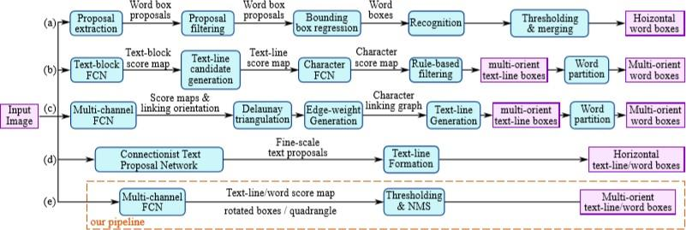

#### **Fig 1. Comparison of pipelines of several recent works on scene text detection**

**2.1.3Text Recognition**

Recognizing text in images is a research problem that has attracted significant interest in the last few years due to its numerous potential applications in document image analysis, image retrieval, scene understanding, visual assistance, and so on. Early work focused on images of printed text, which can be interpreted with traditional sliding-window based Optical Character Recognition (OCR) techniques. In the last few years, great progress has been made with the development of methods that use deep convolutional neural networks (CNNs) to “spot text” in natural scene images, that is, to both locate text target regions and then recognize the words in these regions.

Although tremendous efforts have been devoted to improving the performance text spotting models, being able to read text automatically in arbitrary images is still extremely challenging and remains an open problem. This even applies to the seemingly “easy” domain of document images when they include photographs of natural scenes with text overlays. We collected such images and offer a new large dataset with ground-truth labels, which we make publicly available. We scanned almost 8,000 pages of historic interior design catalogues. The pages show photos of home interiors and furniture, text descriptions that include hundreds of thousands of words, and prices. Analysis of this data is difficult due to the placement of the text in the photos and scanning artifacts.

The motivations of the sequence-to-sequence semantic based spelling correction model are three fold. Firstly, the sequence-to-sequence model is used to translate a data sequence into another data sequence and widely used in the fields of machine translation, audio recognition, etc. Based on this, we treat predicted results from text recognition as input sequences and treat corrected results as output sequences to reach our spelling correction goal. Secondly, in order to take advantage of domain knowledge, the inputs to our model are phrases of words rather than single words, so that the model can combine domain knowledge context to correct the result of our text recognition module. Thirdly, for the purpose of making the model to be more effective in combining“ front and back memory information” when correcting the spelling of words, we implemented a bidirectional Long Short-Term Memory (LSTM) network in the encoder part of our sequence-to-sequence model.

[RikuAnegawa](https://ieeexplore.ieee.org/author/37087081820)et proposed that,. R2CNN generates region proposal for each CNN feature map by using the Region Proposal Network (RPN). For each box generated by RPN, three ROI Poolings with different pooled sizes, namely, 7×7, 3×11, and 11×3, are performed. While Faster R-CNN

[15] uses ROI Poolings with pooled size of 7×7 only, R2CNN does the poolings with the three sizes to handle horizontal or vertical texts. The pooled features are then concatenated, and text/non-text scores, axis-aligned boxes and inclined minimum area boxes are predicted. The inclined boxes are processed by inclined non-maximum suppression and the detection results are ﬁnally generated.

One of the problems is that more than one bounding box may appear on a book. We therefore intend to group bounding boxes which belong to an identical book. To address the problem, we consider two features. One is that detected bounding boxes of a book should be located closely and have angles similar to that of the book. We ﬁrst sort all bounding boxes obtained by the R2CNN in spatial order and get the top bounding box of each book. Then, we calculate the range of each book with the top bounding box.

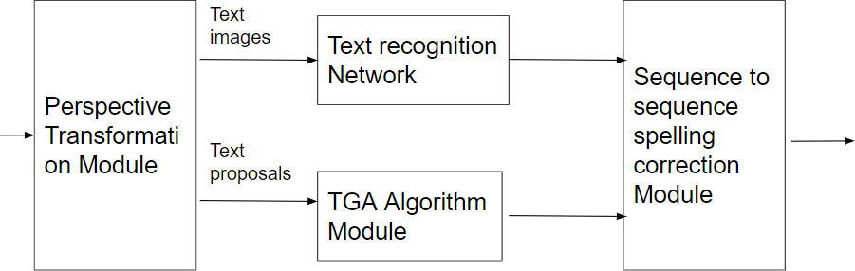Yi Zheng et al.,[3] stated that,The four modules are a perspective transformation module, a text recognition module, a text grouping and arranging module, and a text spelling correction module.

#### **Fig 2 Describing modules in semantic based text recognition**

2**.1.4 EAST (Efficient and Accurate Scene Text) Detector:**

This algorithm was proposed by Xinyu Zhou , Cong Yao , He Wen , Yuzhi Wang , Shuchang Zhou , Weiran He , Jiajun Liang . The algorithm is tested on 2 datasets in ImageNet which are namely VGG 16 and PVANet.With these two datasets the authors got better results so they trained a Fully Convolutional Network(FCN) with these two datasets.Lets see the architecture of the EAST Algorithm: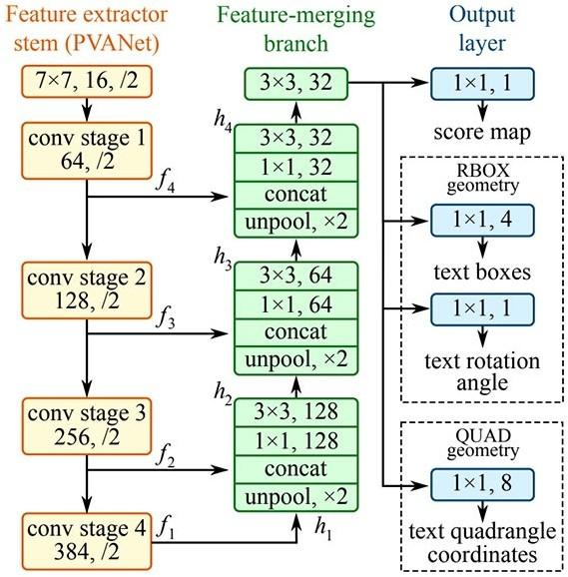

## EAST with PVANet:

#### 

#### **Fig.3 Structure of our text detection FCN with PVANet**

From the above architecture we can describe like the entire Architecture contains 3 Parts namely Feature Extractor Stem of PVANet, Feature-Merging Branch and Output layer. The Description of these layers are as follows:

* 1. **Feature ExtractorStem:**

The stem can be a convolutional network pre-trained on ImageNet dataset, with interleaving convolution and pooling layers. Four levels of feature maps, denoted as fi, are extracted from the stem,

we also adopted the well-known VGG16 model, where feature maps after pooling-2 to pooling-5 are extracted.

### Feature Mergingbranch:

In The Feature-merging branch,we gradually merge them gi={(unpool(hi) if i ≤ 3

{conv3×3(hi) if i = 4

hi= {(fiif i = 1

{conv3×3(conv1×1([gi−1;fi])) otherwise

where giis the merge base, and hi is the merged feature map, and the operator [·;·] represents concatenation along the channel axis. In each merging stage, the feature map from the last stage is ﬁrst fed to an unpooling layer to double its size, and then concatenated with the current feature map. Next, a conv1×1 bottleneck cuts down the number of channels and reduces computation, followed by a conv3×3 that fuses the information to ﬁnally produce the output of this merging stage. Following the last merging stage, a conv3×3 layer produces the ﬁnal feature map of the merging branch and feed it to the output layer.

### Output layer:

The number of output channels for each convolution is shown below. We keep the number of channels for convolutions in branch small, which adds only a fraction of computation overhead over the stem, making the network computation-efﬁcient. The ﬁnal output layer contains several conv1×1 operations to project 32 channels of feature maps into 1 channel of score map Fs and a multi-channel geometry map Fg. The geometry output can be either one of RBOX or QUAD, summarized in Table below.

For RBOX,the geometry is represented by channels of axis-aligned bounding box (AABB) R and 1 channel rotation angle θ. The 4 channels represent 4 distances from the pixel location to the top, right, bottom, left boundaries of the rectangle respectively.

|  |  |  |
| --- | --- | --- |
| **Geometry** | **Channels** | **Description** |
| AABB | 4 | G = R = {di|i∈{1,2,3,4}} |
| RBOX | 5 | G = {R,θ} |
| QUAD | 8 | G = Q = {(∆xi,∆yi)|i∈{1,2,3,4}} |

#### Table 1 Output Geometry Design

For QUAD Q, we use 8 numbers to denote the coordinate shift from four corner vertices {pi|i∈{1,2,3,4}} of the quadrangle to the pixel location. As each distance offset contains two numbers (∆xi,∆yi), the geometry output contains 8 channels.

## 2.1.4.2 EAST withVGG16:

VGG16 is a convolutional neural network model proposed by K. Simonyan and A. Zisserman from the University of Oxford in the paper “Very Deep Convolutional Networks for Large-Scale Image Recognition”. The model achieves 92.7% top-5 test accuracy in ImageNet, which is a dataset of over 14 million images belonging to 1000 classes. It was one of the famous models submitted to [ILSVRC-2014](http://www.image-net.org/challenges/LSVRC/2014/results).

It makes an improvement over AlexNet by replacing large kernel-sized filters (11 and 5 in the first and second convolutional layer, respectively) with multiple 3×3 kernel-sized filters one after another. VGG16 was trained for weeks and was using NVIDIA Titan BlackGPU’s.

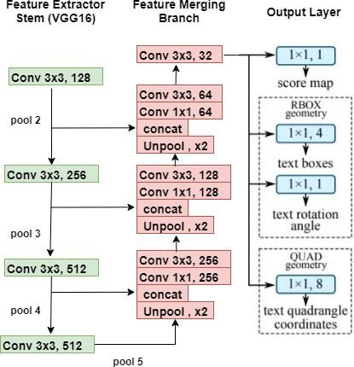

#### **Fig 4 Structure of our text detection FCN with VGG16**

It also contains same 3 layers

* 1. **Feature ExtractorStem:**

For the stem of architecture, it takes the output from the VGG16 model after pool2, pool3, pool4, and pool5 layers.

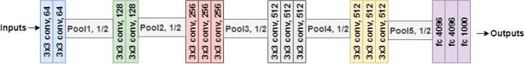

#### **Fig 5 VGG 16 Architecture**

This branch of the network is used to extract features from different layers of the network. This stem can be a convolutional network pretrained on the Image Net dataset.

### Feature Merging Branch:

In this branch of the EAST network, it merges the feature outputs from a different layer of the VGG16 network. The input image is passed through the VGG16 model and outputs from different four layers of VGG16 are taken. Merging these feature maps will be computationally expensive.

That’s why EAST uses a U-net architecture to merge feature maps gradually as shown in architecture figure. Firstly, outputs after the pool5 layer are upsampled using a deconvolutional layer. Now the size of features after this layer would be equal to outputs from the pool4 layer and both are then merged into one layer. Then Conv 1×1 and Conv 3×3 are applied to fuse the information and produce the output of this merging stage.

Similarly outputs from other layers of the VGG16 model are concatenated and finally, a Conv 3×3 layer is applied to produce the final feature map layer before the output layer.

### Output layer:

The output layer is as same as described in above PVANet Architecture.

## **2.1.5 Text Recognition Using Tesseract OCR Pipe line:**

To Know how the text recognition works using tesseract OCR Pipeline,we have to know about Tesseract.

### **2.1.5.1 Tesseract:**

Tesseract was originally developed at Hewlett-Packard Laboratories between 1985 and 1994. In 2005, it was open-sourced by HP. As per wikipedia-*In 2006,* ***“Tesseract was considered one of the most accurate open-source OCR engines then available. “***

The capability of the Tesseract was mostly limited to structured text data. It would perform quite poorly in unstructured text with significant noise. Further development in tesseract has been sponsored by Google since 2006.

Deep-learning based methods perform better for the unstructured data. Tesseract 4 added deep-learning based capability with LSTM network(a kind of Recurrent Neural Network) based OCR engine which is focused on the line recognition but also supports the legacy Tesseract OCR engine of Tesseract 3 which works by recognizing character patterns. The latest stable version 4.1.0 is released on July 7, 2019. This version is significantly more accurate on the unstructured text as well.Tesseract library is shipped with a handy command line tool called tesseract. We can use this tool to perform OCR on images and the output is stored in a text file.

#### **2.1.5.2 Tesseract Basic Usage:**

* + 1. **Input filename:** We use image.jpg in the examples below.
    2. **OCR language:** The language in our basic examples is set to English (eng). On the command line and pytesseract, it is specified using the -option.
    3. **OCR Engine Mode (oem):** Tesseract 4 has two OCR engines:
       1. Legacy Tesseract engine
       2. LSTM engine.

There are four modes of operation chosen using the --oem option.

1. Legacy engine only.
2. Neural nets LSTM engine only.
3. Legacy + LSTM engines.
4. Default, based on what is available.

#### Page Segmentation Mode(psm):

PSM can be very useful when you have additional information about the structure of the text.

#### **2.1.5.3 OCR Engine:**

Optical Character Recognition, or OCR, is a technology that enables you to convert different types of documents, such as scanned paper documents, PDF files or images captured by a digital camera into editable and searchable data.

Optical Character Recognition abbreviated as OCR is the software tool used to convert typed or handwritten content into machine readable, editable format. OCR engines are used to read typed (machine printed) characters. The easy and quick reading of upper/lower case letters, accented letters, symbols and punctuations are performed. The broken characters, text lines, etc are also easily recognized.

The Tesseract v4 uses LSTM based OCR Engine by default to get digits recognised. So lets see about LSTM.

#### **2.1.5.3 LSTM(Long Short Term Memory):**

Long short-term memory (LSTM) is an artificial recurrent neural network (RNN) architecture used in the field of deep learning. Unlike standard feed forward neural networks, LSTM has feedback connections. It can not only process single data points (such as images), but also entire sequences of data (such as speech or video). For example, LSTM is applicable to tasks such as unsegmented, connected handwriting recognition, speech recognition and anomaly detection in network traffic or IDS (intrusion detection systems).

A common LSTM unit is composed of a cell, an input gate, an output gate and a forget gate. The cell remembers values over arbitrary time intervals and the three gates regulate the flow of information into and out of the cell.

There are several architectures of LSTM units. A common architecture is composed of a cell (the memory part of the LSTM unit) and three regulators. usually called gates, of the flow of information inside the LSTM unit: an input gate, an output gate and a forget gate. Some variations of the LSTM unit do not have one or more of these gates or maybe have other gates. For example, gated recurrent units (GRUs) do not have an output gate.

There are connections into and out of the LSTM gates, a few of which are recurrent. The weights of these connections, which need to be learned during training, determine how the gates operate.

Now we will combine all these 3 into a single package to work together.we will call it the Tesseract LSTM based OCR Engine.

#### **2.1.5.4 Tesseract LSTM based OCR Engine**:

Tesseract LSTM OCR can read eleven different languages (English, Danish, Dutch, Finnish, French, German, Italian, Norwegian, Portuguese, Spanish, and Swedish). The primary character classifier function in Tesseract OCR is based on an implementation of a Long Short-Term Memory neural network or LSTM network. LSTM neural networks outperform all other alternative neural network architecture models for this type of pattern recognition and also outperform the more "classical" character recognition algorithms used by the top selling commercial OCR products. For example, an LSTM network achieved the best known results in unsegmented connected handwriting recognition, and in 2009 won the ICDAR handwriting competition.

The accuracy of an LSTM network is heavily dependent on the training data. The training data used in the new Tesseract LSTM included a significant amount of degraded images produced by cameras. If Tesseract's LSTM recognizer fails on a particular character sequence, it can "fall-back" to its generic static shape classifier to make the determination. Implementation of Tesseract's LSTM neural network OCR engine takes about 6 seconds to read a 5.0 MPimage.

**2.1.6 Non-Maximum Suppression**

Object detectors have hugely profited from moving towards an end-to-end learning paradigm: proposals, features, and the classifier becoming one neural network improved results two-fold on general object detection. One indispensable component is non-maximum suppression (NMS), a post-processing algorithm responsible for merging all detections that belong to the same object.

Present-day detectors do not return all detections that have been scored, but instead use NMS as a post-processing step to remove redundant detections. In order to have true end-to-end learned detectors, we are interested in detectors without any post-processing. To understand why NMS is necessary, it is useful to look at the task of detection and how it is evaluated.

**Object detection**:

The task of object detection is to map an image to a set of boxes: one box per object of interest in the image, each box tightly enclosing an object. This means detectors ought to return exactly one detection per object. Since uncertainty is an inherent part of the detection process, evaluations allow detections to be associated to a confidence. Confident erroneous detections are penalized more than less confident ones. In particular mistakes that are less confident than the least confident correct detection are not penalized at all.

**Detectors do not output what we want**:

The detection problem can be interpreted as a classification problem that estimates probabilities of object classes being present for every possible detection in an image. This viewpoint gives rise to “hypothesize and score” detectors that build a search space of detections (e.g. sliding window, proposals) and estimate class probabilities independently for each detection. As a result, two strongly overlapping windows covering the same object will both result in high score since they look at almost identical image content. In general, instead of one detection per object, each object triggers several detections of varying confidence, depending on how well the detection windows cover the object.

**Greedy NMS:**

Since the actual goal is to generate exactly one detection per object (or exactly one high confidence detection), a common practice (since at least 1994 [3]) is to assume that highly overlapping detections belong to the same object and collapse them into one detection. The predominant algorithm (Greedy NMS) accepts the highest scoring detection, then rejects all detections that overlap more than some threshold ϑ and repeats the procedure with the remaining detections, i.e. greedily accepting local maxima and discarding their hence the name. This algorithm eventually also accepts wrong detections, which is no problem if their confidence is lower than the confidence of correct detections.

**Greedy NMS is not good enough:**

This algorithm works well if the suppression is wide enough to always suppress high scoring detections triggered by same object and the suppression is narrow enough to never suppress high scoring detections of the next closest object. If objects are far apart condition is easy to satisfy and a wide suppression works well. In crowded scenes with high occlusion between objects there is a tension between wide and narrow suppression. In other words with one object per image NMS is trivial, but highly occluded objects require a better NMS algorithm.

The de facto standard NMS algorithm is still fully hand-crafted, suspiciously simple, and -- being based on greedy clustering with a fixed distance threshold -- forces a trade-off between recall and precision. We propose a new network architecture designed to perform NMS, using only boxes and their score. We report experiments for person detection on PETS and for general object categories on the COCO dataset. Our approach shows promise providing improved localization and occlusion handling.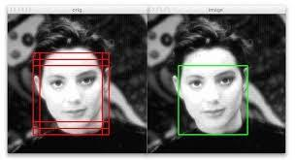

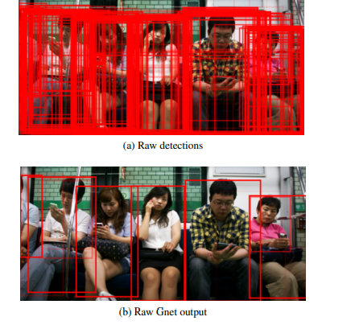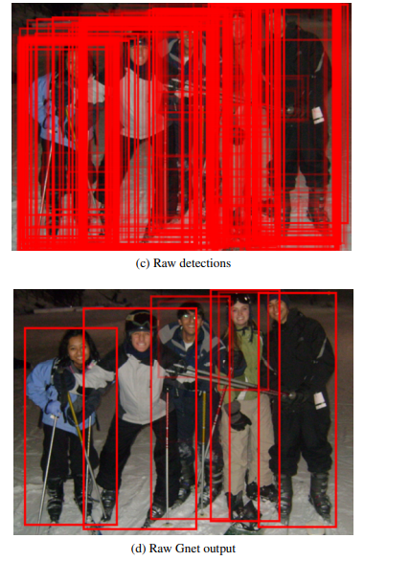

**Fig 6 Example of Non-Maximum Suppression**

**2.1.7 Fully Convolutional Network (FCN)**

Fully Convolutional Network (FCN) for Semantic Segmentation is briefly reviewed. Compared with classification and detection tasks, segmentation is a much more difficult task.

* Image Classification: Classify the object (Recognize the object class) within an image.
* Object Detection: Classify and detect the object(s) within an image with bounding box(es) bounded the object(s). That means we also need to know the class, position and size of each object.
* Semantic Segmentation: Classify the object class for each pixel within an image. That means there is a label for each pixel.

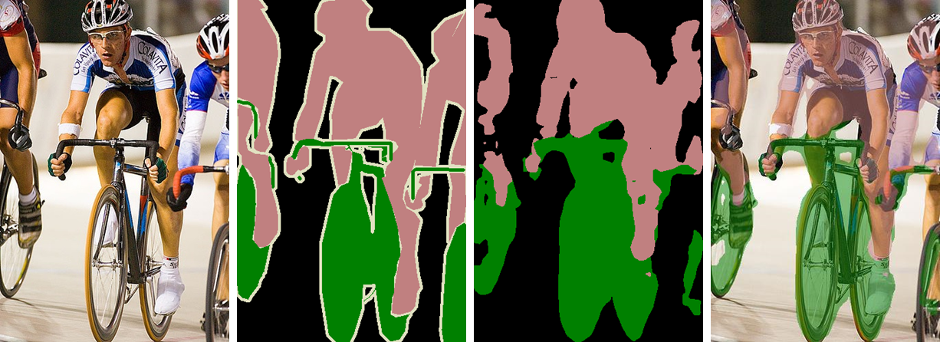

Original Image (Leftmost), Ground Truth Label Map (2nd Left), Predicted Label Map (2nd Right), Overlap Image and Predicted Label (Rightmost)

It has been published in 2015 CVPR [1] and 2017 TPAMI [2] with citations more than 6000 while I was writing this story. Thus, it is also one of the most basic papers for semantic segmentation using FCN. ([Sik-Ho Tsang](https://medium.com/u/aff72a0c1243?source=post_page-----eb8c9b50d2d1--------------------------------) @ Medium)

**1. From Image Classification to Semantic Segmentation**

In classification, conventionally, an input image is downsized and goes through the convolution layers and fully connected (FC) layers, and output one predicted label for the input image, as follows:

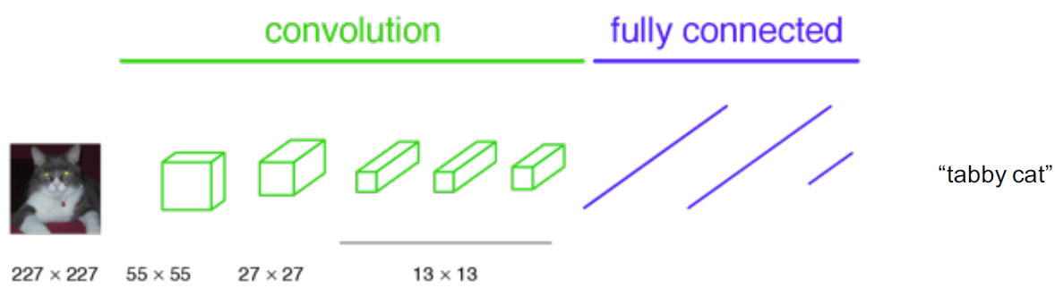

**Fig 7 Classification**

Imagine we turn the FC layers into 1×1 convolutional layers:

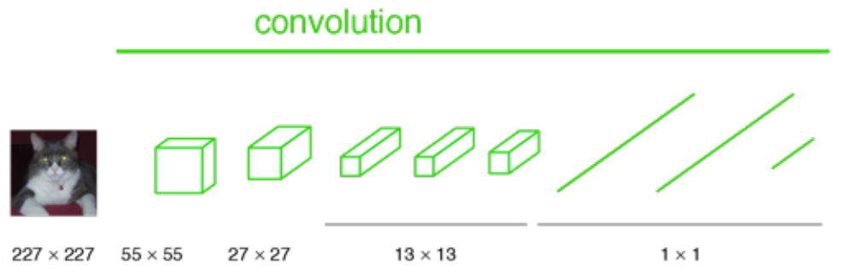

**Fig 8 All layers are convolutional layers**

And if the image is not downsized, the output will not be a single label. Instead, the output has a size smaller than the input image (due to the max pooling):

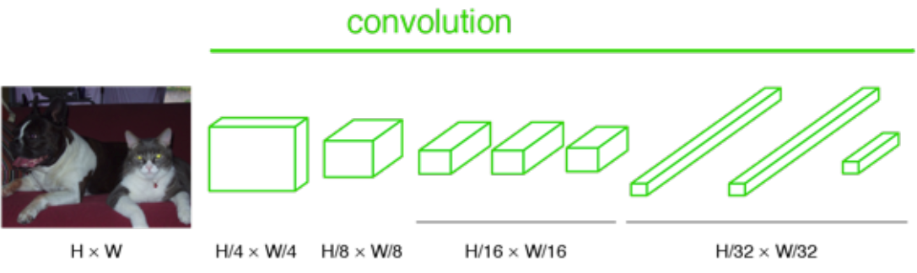

If we up sample the output above, then we can calculate the pixel wise output (label map) as below:

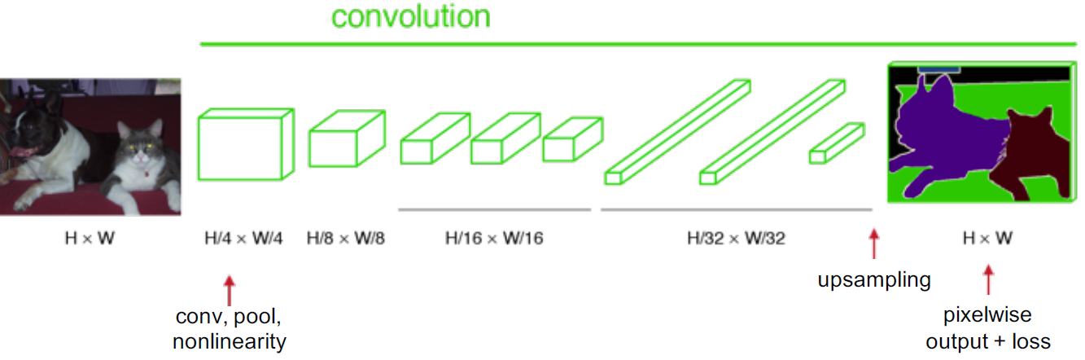

**Fig 9 Up sampling at the last step**

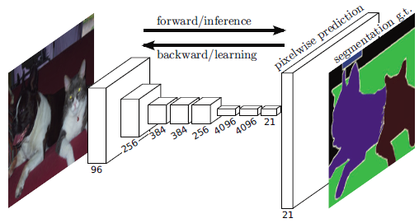

**Fig 10 Feature Map / Filter Number Along Layers**

**2. Upsampling Via Deconvolution**

Convolution is a process getting the output size smaller. Thus, the name, deconvolution, is coming from when we want to have upsampling to get the output size larger. (But the name, deconvolution, is misinterpreted as reverse process of convolution, but it is not.) And it is also called, **up convolution, and transposed convolution.**And it is also called**fractional stride convolution** when fractional stride is used.



**Fig 11 Upsampling Via Deconvolution (Blue: Input, Green: Output)**

**3. Fusing the Output**

After going through conv7 as below, the output size is small, then 32× upsampling is done to make the output have the same size of input image. But it also makes the output label map rough. And it is called **FCN-32s**:

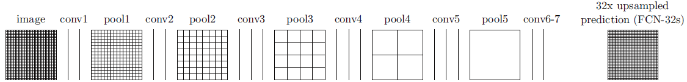

This is because, **deep features can be obtained when going deeper, spatial location information is also lost when going deeper.**That means output from shallower layers have more location information. If we combine both, we can enhance the result.

To combine, we **fuse the output (by element-wise addition)**:

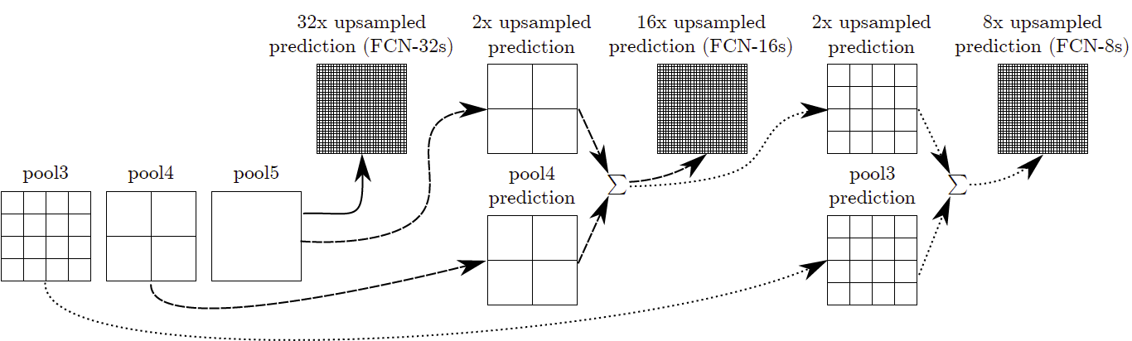

Fusing for FCN-16s and FCN-8s

**FCN-16s**: The **output** from pool5 is 2× upsampled and fuse with pool4 and perform 16× upsampling. Similar operations for **FCN-8s** as in the figure above.

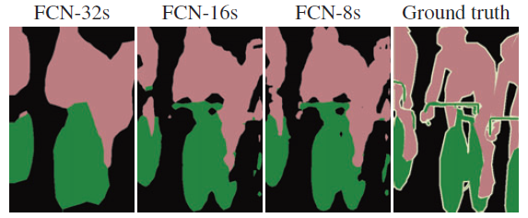

**Fig 12 Comparison with different FCNs**

**FCN-32s result is very rough due to loss of location information** while FCN-8s has the best result.

This fusing operation actually is just like the boosting / ensemble technique used in AlexNet, VGGNet, and GoogLeNet, where they add the results by multiple model to make the prediction more accurate. But in this case, it is done for each pixel, and they are added from the results of different layers within a model.

**4. Results**

* FCN-8s is the best in Pascal VOC 2011.
* FCN-16s is the best in NYUDv2.
* FCN-16s is the best in SIFT Flow.

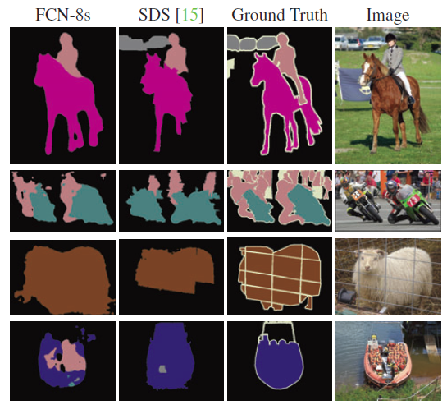

**Fig 13 Visualized Results Compared**

* 1. **Existing System**

In the existing system it was Proposed Scene Text Detection Method That Consists of two stages: a Fully Convolutional Network and an NMS merging stage. The FCN directly produces text regions, excluding redundant and time-consuming intermediate steps. The pipeline is flexible to produce either word level or line level predictions, whose geometric shapes can be rotated boxes or quadrangles, depending on specific applications.

**2.2.1 Existing System Disadvantages**:

The proposed algorithm performs well only when the image is highly quality. It will not provide correct Results when image has following challenges they are image having sensor noise, viewing angles, blurring and resolution.

* 1. **Proposed System**

We proposed a text detection and recognition system where Test Detection is the process of detecting the text present in the image, followed by surrounding it with a rectangular bounding box. Text Detection can be carried out using image based techniques or frequency based techniques. In image based techniques, an image is segmented into multiple segments.

Step1: we will be importing required modules like CV2, numpy, time, non_max_suppression, pytesseract.

Step2: In the second step we are reading “ frozen_east_text_detection.pb” . This is the main library, the brain of the whole program. It is nothing but the neural network which the east detection team have developed this. It is a frozen neural network library. We are using this in order to detect our systems. In this network they collected wide variety of images and trained their systems to detect these images.

Step3: In the third step we are giving images or video as an input to user defined function text_detection function.

Step4: In text_detection function the input is stored into a variable and checks whether the image is captured or not.

Step5: Saving the image dimensions the reason is we need to format the image into factors of 32. We are resizing the image into 640 width and 320 height using resize() method which is present in cv2.

Step6: We construct a list of layerNames

1.The first layer is our output sigmoid activation which gives us the probability of a region containing text or not.

2 The second layer is the output feature map that represents the “geometry” of the image we’ll be able to use this geometry to derive the bounding box coordinates of the text in the input image.

Step 7: Then we prepare our image by converting it to a blob. By supplying layerNames as a parameter to net.forward, we are instructing OpenCV to return the two feature maps that we are interested in:

* The output geometry map used to derive the bounding box coordinates of text in our input images.
* And similarly, the scores map, containing the probability of a given region containing text.

Step 8: We start off by grabbing the dimensions of the scores volume and then initializing two lists:

* **Rects**  : Stores the bounding box *(x, y)*-coordinates for text regions
* **Confidences** : Stores the probability associated with each of the bounding boxes in rects

We’ll later be applying non-maxima suppression to these regions.

Step 9: we transfer the image to pytesseract with location of bounding boxes around the detected text. The text in the bounding boxes is recognized finally the output is displayed above the bounding boxes.

* 1. **Conclusion:**

We have presented a scene text detector that directly produces word or line level predictions from full images with a single neural network. By incorporating proper loss functions, the detector can predict either rotated rectangles or quadrangles for text regions, depending on specific applications. Successfully integrated text detection with text recognition. The experiments on standard benchmarks confirm that the proposed algorithm substantially outperforms previous methods in terms of both accuracy and efficiency. Successfully integrated text detection with text recognition

**3 ANALYSIS**

**3.1 INTRODUCTION**

In the analysis phase, end user’s requirements are analysed and project goals get converted into the defined system functions that the organization intends to develop. The three primary activities involved in the analysis phase are as follows:

1. Software Requirement Specification
2. Creating content diagram
3. Performing a detailed analysis by drawing a flowchart

Requirement Analysis will identify and consider the risks related to how the technology will be integrated into the standard operating procedures.  Requirements Analysis will also collect the functional and system requirements of the business process, the user requirements and the operational requirements. Hence this section deals with the software and hardware requirements with respect to our project.

**3.2 SOFTWARE REQUIREMENT SPECIFICATION**

Requirement Determination is the process, by which analyst gains the knowledge of the organization and apply it in selecting the right technology for an application.

A Software requirement specification (SRS) is a complete description of the behavior of the system to be developed. It includes a set of use cases that describe all the interactions the users will have with the software. Use case is also known as functional requirements. In addition to use cases, the SRS also contains non-functional (or supplementary requirements Non-functional requirements are requirements which impose constraints on the design and implementation (such as performance engineering requirements, quality standards, or design constraints).

**FUNCTIONAL REQUIREMENTS**

In software engineering, a functional requirement defines a function of a software system or its component. A function is described as a set of inputs, the behavior, and outputs. Functional requirements may be calculation, technical details, data manipulation and processing and other specific functionality that define what a system is supposed to accomplish. Behavioral requirements describing all the cases where the system uses the functional requirements are captured in use cases. Functional requirements are supported by non-functional requirements (also known as quality requirements), which impose constraints the design or implementation such as performance requirements, reliability, and security. How a system implements functional requirements is detailed in the system design. In some cases, a requirements analyst generates use cases after gathering and validating a set of functional requirements. Often though, an analyst will begin by selecting a set of use cases, from which the analyst can derive the functional requirements that must be implemented to allow a user to perform each use case.

**NON-FUNCTIONAL REQUIREMENTS**

In systems engineering and requirements engineering a non-functional requirement is a requirement that specifies criteria that can be used to judge the operation of a system, rather than specific behaviors. This should be contrasted with functional requirements that define specific behavior or functions. In general, functional requirements define what a system is supposed to do whereas non-functional requirements are often called qualities of a system. Other terms for non-functional requirements are “constraints”, “quality goals” and “quality of service requirements”, and “non-behavioral requirements”. Quality that is non-functional requirements can be divided into two main categories.

**3.2.1 USER REQUIREMENTS**

In the user requirements we get the description of the users who uses the system along with their characteristics and it specifies the product. It also describes briefly about the functional and data requirements of the project.

User requirements for this project are;

* PYTHON IDLE
* DJANGO

**3.2.2 SOFTWARE REQUIREMENTS**

Software Requirements deal with defining software resource requirements and pre-requisites that need to be installed on a computer to provide optimal functioning of an application. These requirements or pre-requisites are generally not included in the software installation package and need to be installed separately before the software is installed.

Operating System : Windows (XP,8.1,10)

Software Used :Python Idle, Django

**3.2.3 HARDWARE REQUIREMENTS**

The most common set of requirements defined by any operating system or software application is the physical computer resources also known as hardware. A hardware requirements list is often accompanied by a hardware compatibility list (HCL), especially in case of operating systems. An HCL lists tested, compatible hardware devices for a particular operating system or application. The following subsections discuss the various aspects of hardware requirements.

CPU type : Intel Core i3

RAM : 4GB

System Type : 64-bit operating System

Requirements - 2GB Minimum Disk Space

**3.4 FLOWCHART OF THE CODE**

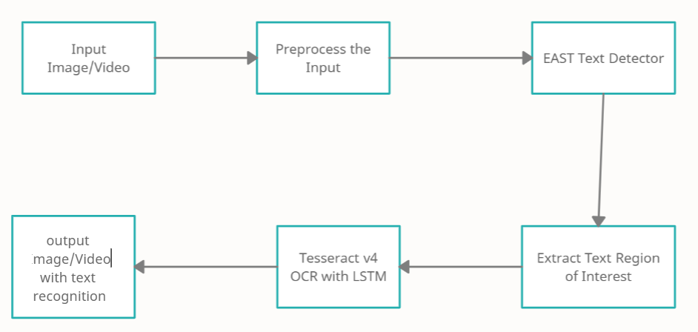

Fig 14 Flow Chart

**3.5 CONCLUSION**

This chapter starts with the introduction of analysis in general followed by Software Requirement Specification which contains software requirements and hardware requirements i.e. what are the software’s required to implement and run the system and hardware requirements required for establishing and running the project.

**4. DESIGN**

**4.1 INTRODUCTION**

Software Design is a process of planning the new or modified system. The design step produces the understanding and procedural details necessary for implementing the system recommended in the feasibility study. Analysis specifies what a new or modified system does. Design specifies how to accomplish the same. Design is essentially a bridge between requirement specification and the final solution satisfying the requirement. It is a blue print or a solution for the system. The design step produces a data design, an architectural design and procedural design.

The design process for a software system has two levels. At first level the focus is on depending in which modules are needed for the system, the specification of these modules and how the modules should be interconnected. This is what is called system designing of top level design. In the second level, the internal design of the modules, or how the specification should be interconnected.

**Top Level Design**

It is the first level of the design which produces the system design, which defines the components needed for the system, and how the components interact with each other. It focus is on depending in which the modules are needed for the system, the specification of these module should be interconnected.

**Logic Design**

The logic design of this application shows the major features and how they are related to one another. The detailed specifications are drawn on the bases of user requirements. The outputs, inputs and relationship between the variables are designed in this phase.

**Input Design**

The input design is the bridge between users and information system. It specifies the manner in which the data enters the system for processing. It can ensure the reliability of the system and produces reports from accurate data or it may result in the output of error information. While designing the following points have to be taken into consideration:

Input Formats are designed as per user requirements.

* Interaction with the user is maintained in simple dialogues.

Appropriate fields are designed with validations there by allowing valid inputs

**Output Design**

Each and every presented in the system is result-oriented. The most important feature of this application for users is the output. Efficient output design improves the usability and acceptability of the system and also helps in decision making. Thus, the following points are considered during the output design:

* What information to be present?
* How to display the results?

**Data Design**

Data design is the first of the three design activities that are conducted during software engineering. The impact of data structure on program structure and procedural complexity causes data design to have a profound influence on software quality.

**Architectural Design**

The architectural design defines the relationship among major structural components into a procedural description of the software.

* The use cases are the functions that are to be performed in the module.
* An actor could be end-user of the system or an external system.

**System testing**

System design is the process of defining the architecture, components, modules, interfaces and data for a system to satisfy the specified requirements. System design could see it’s application of systems theory to product development. There is an overlap with the disciplines of system analysis, system architecture and system engineering.

Grady Booch, James Raumbaugh and Ivor Jacobson have collaborated to combine the best features of their individual object oriented analysis and design methods into a unified method the unified modeling language, the version 1.0 for the Unified modeling was released in January 1997 the main parts of UML are based on the Brooch, OMT and OOSE methods.

The goals of UML are:

* To model systems using object-oriented concepts
* To establish an explicit coupling between conceptual as well as executable
* To address the issues of scale inherent in complex, mission critical system
* To create a modeling language usable by both humans and machines.

##### 4.2 BASIC BUILDING BLOCKS OF UML

The basic building blocks in UML are things and relationships; these are combined in different ways following different rules to create different types of diagrams. In UML there are 8 types of diagrams, below is a list and brief description of them. The more in-depth descriptions in the document, will focus on the first five diagrams in the list, which can be seen as the most general, sometimes also referred to as the UML core diagrams.

* **Use Case Diagrams**: it shows a set of use cases, and how actors can use them.
* **Class Diagrams**: describes the structure of the system, divided in classes with different connections and relationships.
* **Sequence Diagrams**: it shows the interaction between a set of objects, through the messages that may be dispatched between them.
* **State Chart Diagram**: state machines, consisting of states, transitions, events and activities.
* **Activity Diagrams**: shows the flow through a program from as defined start point to an end point.
* **Object Diagrams**: A set of objects and their relationships; this is a snapshot of instances of the things found in the class objects.
* **Collaboration Diagrams**: shows organizations and dependencies among a set of components. These diagrams address the static implementation view of the system.
* **Deployment Diagrams**: show the configuration of run-time processing nodes and components that live on them.

**4.2.1 UML DIAGRAMS**

These are the artifacts of a software-intensive system. The abbreviation for UML is Unified Modeling Language and is being brought of a designed to make sure that the existing ER Diagrams which do not serve the purpose will be replaced by this UML Diagrams where in these language as its own set of Diagrams.

Some of the Diagrams that help for the Diagrammatic Approach for the Object-Oriented Software Engineering are:

* Class Diagrams
* Use Case Diagrams
* Sequence Diagrams

Using the above-mentioned diagrams, we can show the entire system regarding the working of the system or the flow of control and sequence of flow and the activities involved in the system.

**4.2.1.1 CLASS DIAGRAM**

A Class is a category or group of things that has similar attributes and common behavior. A Rectangle is the icon that represents the class it is divided into three areas. The upper most area contains the name; the middle area contains the attributes and the lowest areas show the operation. Class diagrams provides the representation that developers work from.

The classes in a Class diagram represent both the main objects, interactions in the application and the classes to be programmed.

In the diagram, classes are represented with boxes which contain three parts:

1. The top part contains the name of the class. It is printed in bold and cantered, and the first letter is capitalized.
2. The middle part contains the attributes of the class. They are left-aligned, and the first letter is lowercase.
3. The bottom part contains the methods the class can execute. They are also left-aligned, and the first letter is lower case. In the design of a system, a number of classes are identified and grouped together in a class diagram which helps to determine the static relations between those objects. With detailed modeling, the classes of the conceptual design are often split into a number of subclasses.

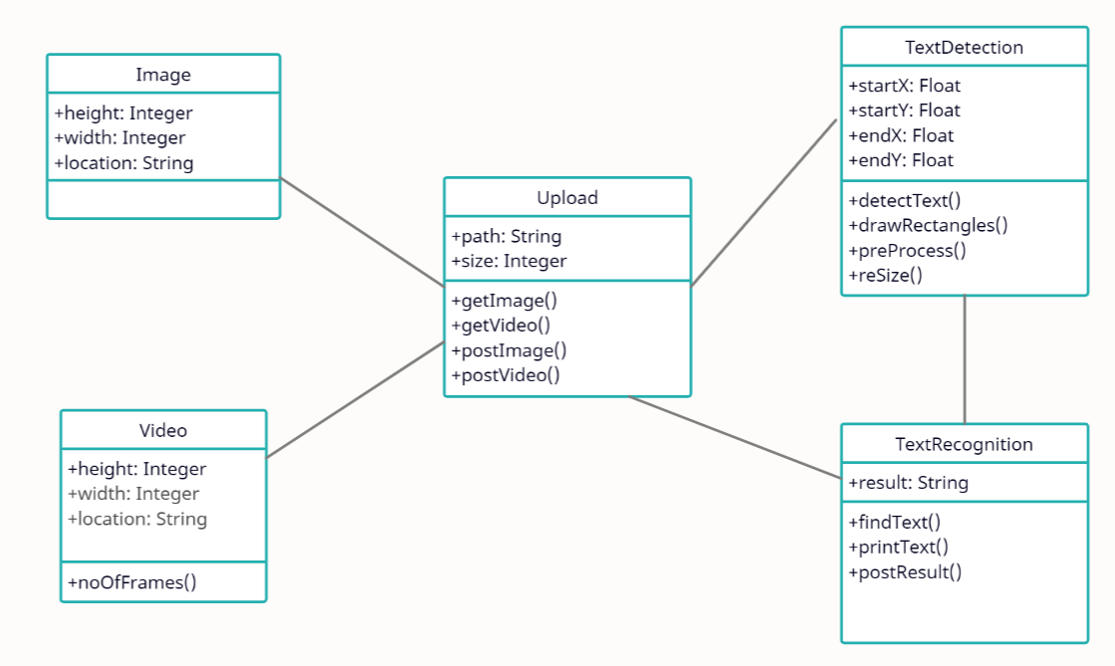

**Fig. 15 Class Diagram**

**Relationships:**

A relationship is general terms covering the specific types of logical connections found on class and object diagrams. UML shows the following relationships:

1. **Links:** A Link is the basic relationship among objects.
2. **Association:** An association represents a family of links. An association can be named and the ends of an association can be adorned with role names, ownership indicators, Multiplicity, visibility, and other properties.



1. **Aggregation:** Aggregation is a variant of the "has a" association relationship; aggregation is more specific than association. It is an association that represents a part whole or part-of relationship. As a type of association, an aggregation can be named and have the same adornments that an association can. In UML, it is graphically represented as a hollow diamond shape on the containing class with a single line that connects it to the contained class. The aggregate is semantically an extended object that is treated as a unit in many operations, although physically it is made of several lesser objects.

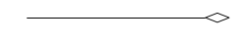

1. **Composition:** Composition is a stronger variant of the "has a" association relationship; composition is more specific than aggregation. Composition usually has a strong lifecycle dependency between instances of the container class and instances of the contained class(es).The UML graphical representation of a composition relationship is a filled diamond shape on the containing class end of the tree of lines that connect contained class(es) to the containing class.

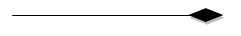

1. **Generalization**: The Generalization relationship ("is a") indicates that one of the two related classes (the subclass) is considered to be a specialized form of the other (the super type) and the super class is considered a 'Generalization' of the subclass. The UML graphical representation of a Generalization is a hollow triangle shape on the super class end of the line (or tree of lines) that connects it to one or more subtypes. The generalization relationship is also known as the inheritance or "is *a"*relationship. Generalization can only be shown on class diagrams and on Use case diagrams.
2. **Realization:** In UML modeling, a realization relationship is a relationship between two model elements, in which one model element realizes (implements or executes) the behavior that the other model element specifies. The UML graphical representation of a Realization is a hollow triangle shape on the interface end of the *dashed* line (or tree of lines) that connects it to one or more implementers. A plain arrowhead is used on the interface end of the dashed line that connects it to its users. Realizations can only be shown on class or component

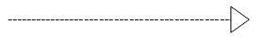

1. **Dependency:** Dependency is a weaker form of bond which indicates that one class depends on another because it uses it at some point in time. One class depends on another if the independent class is a parameter variable or local variable of a method of the dependent class.

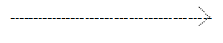

**4.2.1.2 USE-CASE DIAGRAM**

A Use-Case is a description of systems behavior from a understand point. For system developer this is a valuable tool: it’s a tried-and-true technique for gathering system requirements from a user’s point of view. That is important if the goal is to build a system that real people can use. A little stick figure is used to identify an actor the ellipse represents use-case.

**Use cases**

A use case describes a sequence of actions that provide something of measurable value to an actor and is drawn as a horizontal ellipse

**Actors**

An actor is a person, Organization, or external system that plays a role in one or more interactions with your system. Actors are drawn as stick figures.

### **Associations**

Associations between actors and use case are indicated in use case diagrams by solid lines. An association exists whenever an actor is involved with an interaction described by a use case. Associations are modeled as lines connecting use cases and actors to one another, with an optional arrowhead on one end of the line. The arrowhead is often used to indicating the direction of the initial invocation of the relationship or to indicate the primary actor within the use case.

**Use Case Relationships**

Three relationships among use cases are used often in practice.

**1.Include**

In one form of interaction, a given use case may include another. Include is a directed relationship between two use cases, implying that the behavior of the included use case is inserted into the behavior of the including use case.

**2.Extend**

In another form of interaction, a given use case (the extension) may extend another. This relationship indicates that the behavior of the extension use case may be inserted in the extended use case under some conditions. The notation is a dashed arrow from the extension to the extended use case, with the label<<extend>>.

**3.Generalization**

In the third form of relationship among use cases, generalization/specialization relationship exists. A given use case may have common behaviors, constraints and assumptions to the general use case. The notation is a solid line ending in a hollow triangle drawn from the specialized to the more general use case.

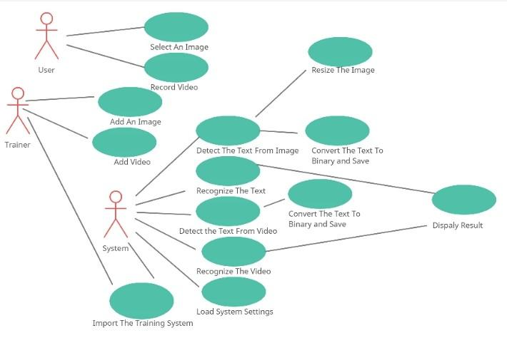

**Fig.16 Use Case Diagram**

**4.2.1.3 SEQUENCE DIAGRAM**

In a functioning system objects interacts with one another and these interactions occur over time. The UML Sequence Diagrams shows the time-based dynamics of the interaction. The sequence diagrams consist of objects represented in the use always named rectangles (If the name underlined), messages represented as solid line arrows and time represented as a vertical progression.

Sequence diagrams describe interactions among classes in terms of an exchange of messages overtime. It is an interaction diagram that emphasizes the time ordering of messages. A narrow rectangle on an object’s lifetime represents activation- an exchange of one of that objects operation. Messages are arrows that connect one.

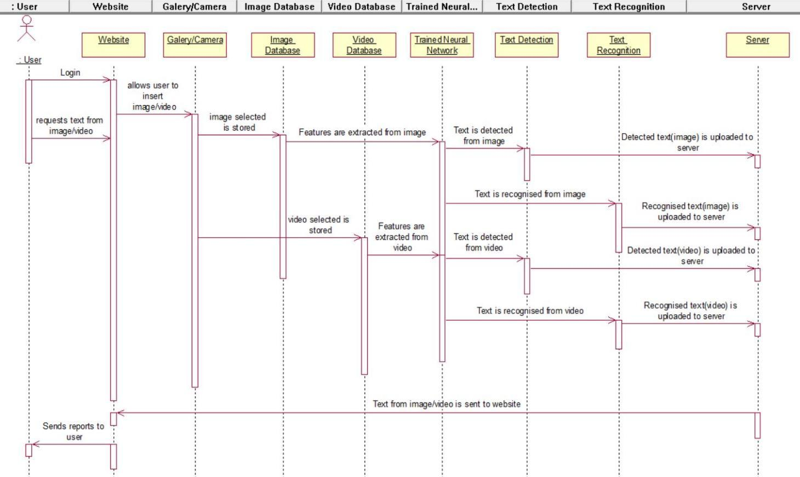

**Fig. 17 Sequence Diagram**

##### 4.2.1.4. STATE CHART DIAGRAM

At any given time, an object is in particular state. One way to characterize change in a system is to say that its objects change the state in response to events and to time. The UML State Diagram captures these kinds of changes it presents the states an object can be in along with the transitions between the states, and shows the starting point and end point of a sequence of state changes. A Rounded Rectangle represents a state, along with the solid line and arrow head that represents a transition. The arrow head points to the state being transition into. The solid circle symbolizes starting point and the bull’s eye that symbolizes the end point.

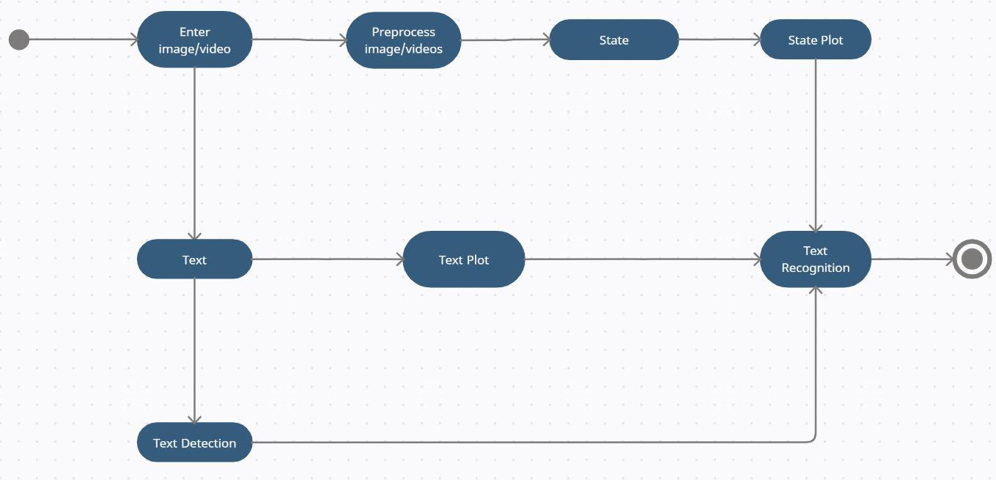

**Fig. 18 State Chart Diagram**

**4.3 CONLUSION**

This chapter starts with the introduction of design in general followed by Basic Building blocks of UML which contains UML diagrams like class diagram, use case diagram, sequence diagram, state chart diagram and activity diagram which describe the structure and behavior.

**5. IMPLEMENTATION AND RESULTS**

**5.1 INTRODUCTION:**

**5.1.1 PYTHON INSTALLATION**

Python is a widely used high-level programming language first launched in 1991. Since then, Python has been gaining popularity and is considered as one of the most popular and flexible server-side programming languages. Unlike most Linux distributions, Windows does not come with the Python programming language by default. However, you can **install Python on our Windows server or local machine** in just a few easy steps.

  Prerequisites

* A system running Windows 10 with admin privileges
* Command Prompt (comes with Windows by default)
* A Remote Desktop Connection app (use if you are installing Python on a remote Windows server)

**Python 3 Installation on Windows**

**Step 1: Select Version of Python to Install**

The installation procedure involves downloading the official Python .exe installer and running it on our system.

The version you need depends on what you want to do in Python. For example, if you are working on a project coded in Python version 2.6, you probably need that version. If you are starting a project from scratch, you have the freedom to choose.

If you are learning to code in Python, you recommend you **download both the latest version of Python 2 and 3**. Working with Python 2 enables us to work on older projects or test new projects for backward compatibility.

**Note**: If you are installing Python on a remote Windows server, log in via[Remote Desktop Protocol (RDP)](https://phoenixnap.com/kb/ssh-to-connect-to-remote-server-linux-or-windows). Once you log in, the installation procedure is the same as for a local Windows machine.

**Step 2: Download Python Executable Installer**

1. Open your browser and navigate to the [Downloads for Windows section](https://www.python.org/downloads/windows/) of the [official Python website](https://www.python.org/).
2. Search for desired version of Python. The latest Python 3 release is version 3.7.3, while the latest Python 2 release is version 2.7.16.

Select a link to download either the **Windows x86-64 executable installer** or **Windows x86 executable installer**. The download is approximately 25MB.

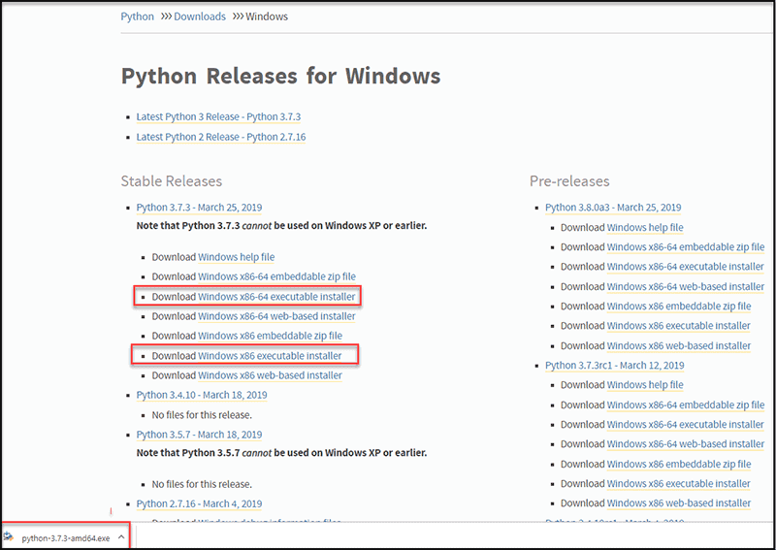

**Screen1 : Python Installer For Windows**

**Step 3: Run Executable Installer**

1. Run the **Python Installer** once downloaded. (In this example, you have downloaded Python 3.7.3.)

2. Make sure you select the **Install launcher for all users** and **Add Python 3.7 to PATH** checkboxes. The latter places the interpreter in the execution path. For older versions of Python that do not support the **Add Python to Path** checkbox, see [Step 6](https://phoenixnap.com/kb/how-to-install-python-3-windows#htoc-step-5-add-python-path-to-environment-variables-optional).

3. Select **Install Now** – the recommended installation options.

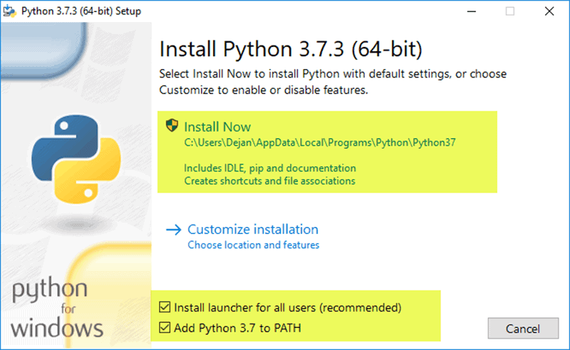

**Screen2 : Installation Of Python**

For all recent versions of Python, the recommended installation options include **Pip** and **IDLE**. Older versions might not include such additional features.

1. The next dialog will prompt you to select whether to **Disable path length limit**. Choosing this option will allow Python to bypass the 260-character MAX_PATH limit. Effectively, it will enable Python to use long path

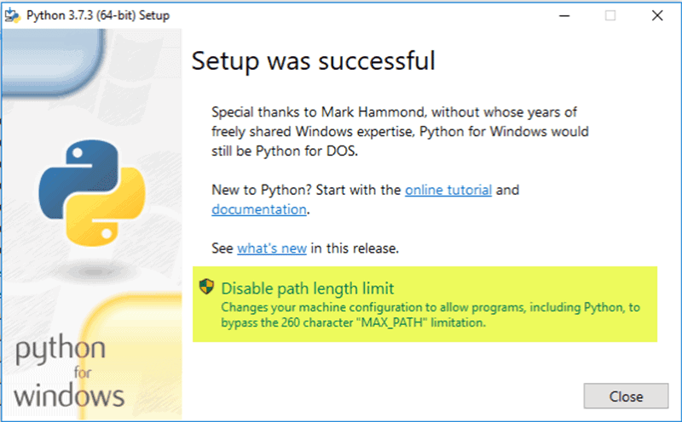

**Screen3: Python Setup was Successful**

4.The **Disable path length** **limit** option will not affect any other system settings. Turning it on will resolve potential name length issues that may arise with Python projects developed in Linux.

**Step 4: Verify Python Was Installed On Windows**

1. Navigate to the directory in which Python was installed on the system. In our case, it is **C:Users*Username*AppDataLocalProgramsPythonPython37**since you have installed the latest version.
2. Double-click **python.exe**.
3. The output should be similar to what you can see below:

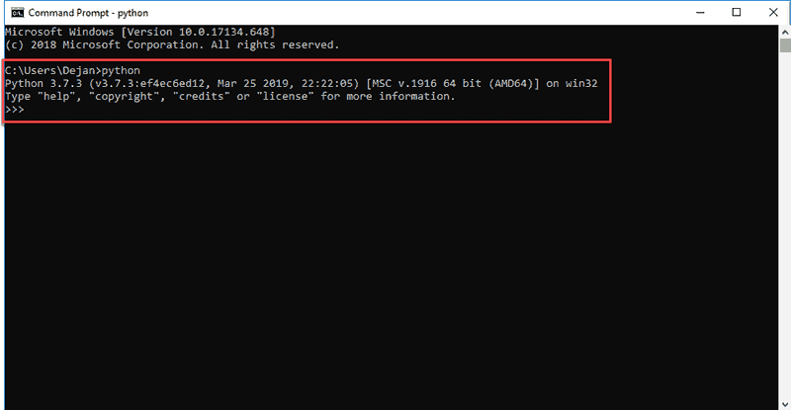

**Screen4: Python Successfully Completed**

**5.1.2 TESSERACT SOFTWARE INSTALLATION:**

**Tesseract** is a Optical Character Recognition engine for various operating systems. It is free software, released under the Apache Liscense. Originally developed by Hewlett Packard as proprietary software in the 1980s, it was released as open source in 2005 and development has been sponsored by since Google 2006.

In 2006, Tesseract was considered one of the most accurate open-source OCR engines then available. The Tesseract engine was originally developed by Hewlett Packard  as proprietary software at  labs in Bristol, England and Greeley, Colorado between 1985 and 1994, with some more changes made in 1996 to port to Windows, and some migration from C to C++ in 1998. A lot of the code was written in C, and then some more was written in C++. Since then all the code has been converted to at least compile with a C++ compiler.[[4]](https://en.wikipedia.org/wiki/Tesseract_(software)#cite_note-Google30Aug06-4) Very little work was done in the following decade. It was then released as open source in 2005 by Hewlett Packard and the University of Nevada, Los Vegas (UNLV). Tesseract development has been sponsored by Google since 2006.

**5.1.2.1Features Of Tesseract Software**:

Tesseract was in the top three OCR engines in terms of character accuracy in 1995. It is available for Linux, Windows and Mac OS X. However, due to limited resources it is only rigorously tested by developers under Windows and Ubuntu.

Tesseract up to and including version 2 could only accept TIFF images of simple one-column text as inputs. These early versions did not include layout analysis, and so inputting multi-columned text, images, or equations produced garbled output. Since version 3.00 Tesseract has supported output text formatting hOCR positional information and page-layout analysis. Support for a number of new image formats was added using the Leptonica library. Tesseract can detect whether text is Monospaced or proportionally spaced.

The initial versions of Tesseract could only recognize English-language text. Tesseract v2 added six additional Western languages (French, Italian, German, Spanish, Brazilian Portuguese, Dutch). Version 3 extended language support significantly to include ideographic (Chinese & Japanese) and right-to-left (e.g. Arabic, Hebrew) languages, as well as many more scripts. New languages included Arabic, Bulgarian, Catalan, Chinese (Simplified and Traditional), Croatian, Czech, Danish, German (Fraktur script), Greek, Finnish, Hebrew, Hindi, Hungarian, Indonesian, Japanese, Korean, Latvian, Lithuanian, Norwegian, Polish, Portuguese, Romanian, Russian, Serbian, Slovak (standard and Fraktur script), Slovenian, Swedish, Tagalog, Tamil, Thai, Turkish, Ukrainian and Vietnamese. V3.04, released in July 2015, added an additional 39 language/script combinations, bringing the total count of support languages to over 100. New language codes included: amh (Amharic), asm (Assamese), aze_cyrl (Azerbaijana in Cyrillic script), bod (Tibetan), bos (Bosnian), ceb (Cebuano), cym (Welsh), dzo (Dzongkha), fas (Persian), gle (Irish), guj (Gujarati), hat (Haitian and Haitian Creole), iku (Inuktitut), jav (Javanese), kat (Georgian), kat_old (Old Georgian), kaz (Kazakh), khm (Central Khmer), kir (Kyrgyz), kur (Kurdish), lao (Lao), lat (Latin), mar (Marathi), mya (Burmese), nep (Nepali), ori (Oriya), pan (Punjabi), pus (Pashto), san (Sanskrit), sin (Sinhala), srp_latn (Serbian in Latin script), syr (Syriac), tgk (Tajik), tir (Tigrinya), uig (Uyghur), urd (Urdu), uzb (Uzbek), uzb_cyrl (Uzbek in Cyrillic script), yid (Yiddish).

In addition Tesseract can be trained to work in other languages.

Tesseract can process right-to-left text such as Arabic or Hebrew, many Indic scripts as well as CJK quite well. Accuracy rates are shown in this presentation for Tesseract tutorial at DAS 2016, Santorini by Ray Smith.

Tesseract is suitable for use as a backend and can be used for more complicated OCR tasks including layout analysis by using a frontend such as OCRopus.

Tesseract's output will have very poor quality if the input images are not preprocessed to suit it: Images (especially screensots) must be scaled up such that the text x-height is at least 20 pixels, any rotation or skew must be corrected or no text will be recognized, low-frequency changes in brightness must be high-pass filtered, or Tesseract's binarization stage will destroy much of the page, and dark borders must be manually removed, or they will be misinterpreted as characters

.

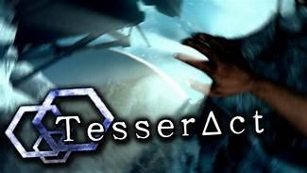

**Screen5: Tesseract software**

**5.1.2.2 How To Download Tesseract Software:**

Downloading Tesseract can be a little confusing, especially if you're not used to working with your Command Line Interface (CLI).

**5.1.2.2.1 Installing Tesseract Software On Windows:**

Tesseract  suggests you use the Tesseract Installer For UB Mannheim (Mannheim University Library). From there, you can download the installer, and simply follow those directions. You can download older versions of Tesseract using the archive on SourceForge or by downloading the Cywin Package Manager and downloading Tesseract through that software.



**Screen6: Tesseract software Installation for windows**

The latest installers can be downloaded here:

* [tesseract-ocr-w32-setup-v5.0.0-alpha.20201127.exe](https://digi.bib.uni-mannheim.de/tesseract/tesseract-ocr-w32-setup-v5.0.0-alpha.20201127.exe) (32 bit) and
* [tesseract-ocr-w64-setup-v5.0.0-alpha.20201127.exe](https://digi.bib.uni-mannheim.de/tesseract/tesseract-ocr-w64-setup-v5.0.0-alpha.20201127.exe) (64 bit) resp.

We don't provide an installer for Tesseract 4.1.0 because we think that the latest version 5.0.0-alpha is better for most Windows users in many aspects (functionality, speed, stability). Version 4.1 is only needed for people who develop software based on the Tesseract API and who need 100 % API compatibility with version 4.0.

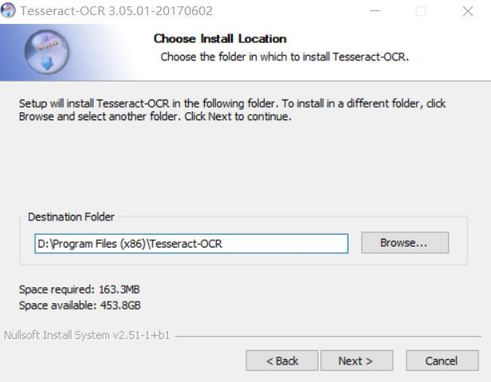

**Screen7: Destination folder for Tesseract software**

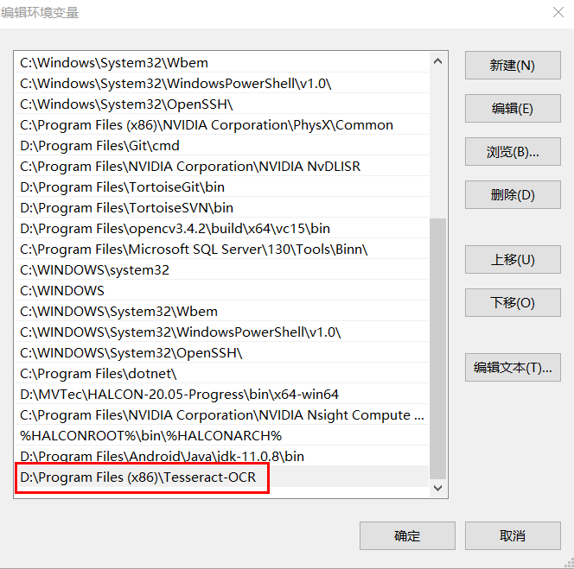

**Screen8: Setting up the destination folder for Tesseract**

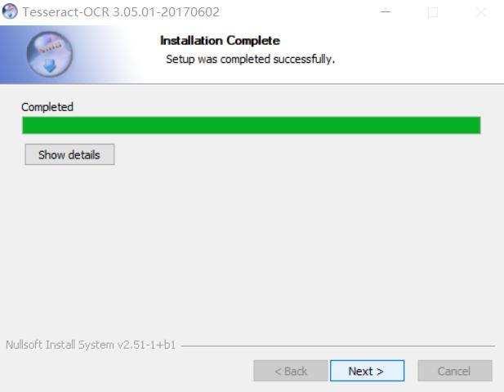

**Screen9: Tesseract software Installed**

**Advantages Of Tesseract OCR:**

The best thing about Tesseract is that it is free and easy to use. Basically it is a [command line tool](https://github.com/tesseract-ocr/tesseract), but there is also a Python wrapper called [pytesseract](https://pypi.org/project/pytesseract/) and the GUI frontend [gImageReader](https://github.com/manisandro/gImageReadergimagereader), so you can choose the one that best fits your purposes.

Using the command line tool is as easy as

tesseractimagenameoutputbase **[outputformat]**

If we don’t specify an output format, the default is a text file containing the recognized characters. Alternatively, pdf will output a searchable pdf, and hocr and alto XML files containing additional information like character positions (in the XML standard which goes by the same name, respectively). See [here](https://github.com/tesseract-ocr/tesseract/wiki/Command-Line-Usage) for more optional arguments.

Here is what Tesseract finds in our test images:

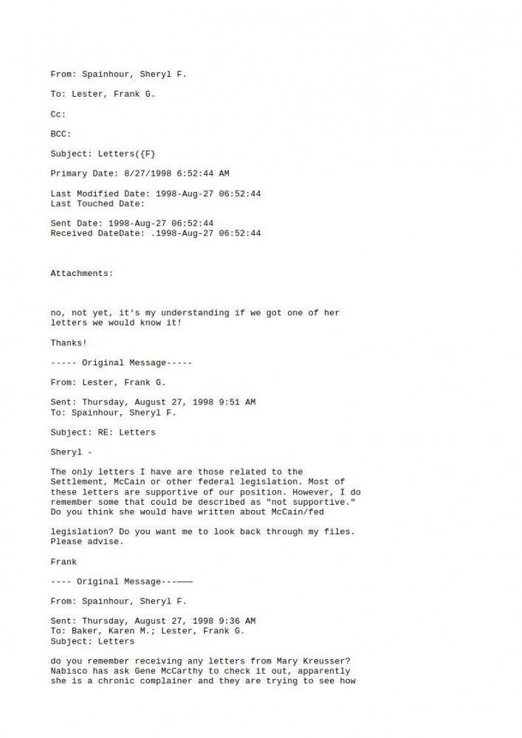

**Screen10: Test Image1 for Tesseract Software**

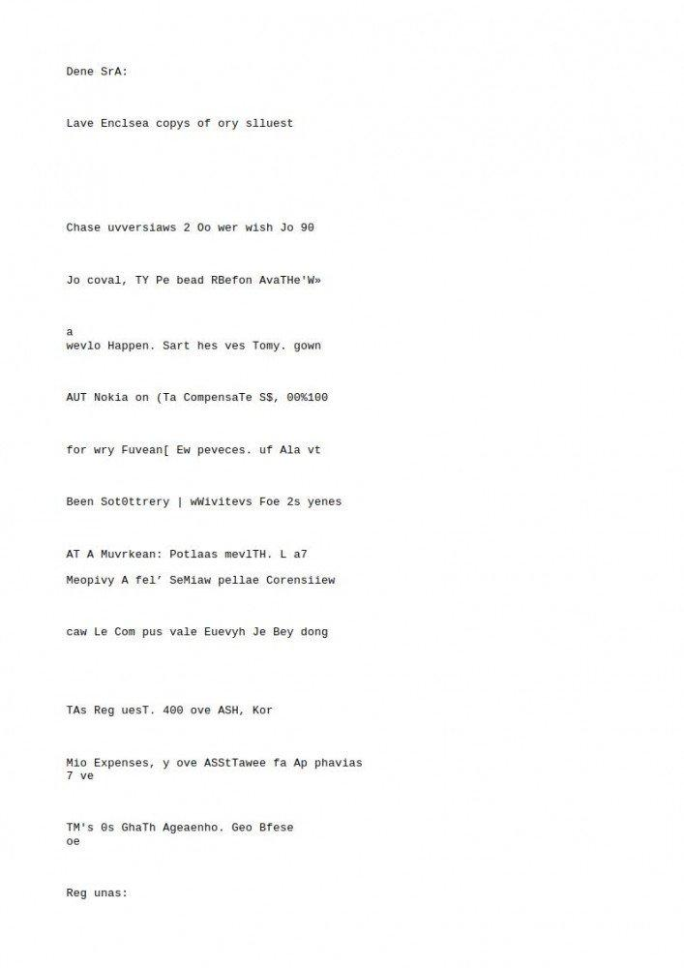

**Screen11: Test Image2 for Tesseract software**

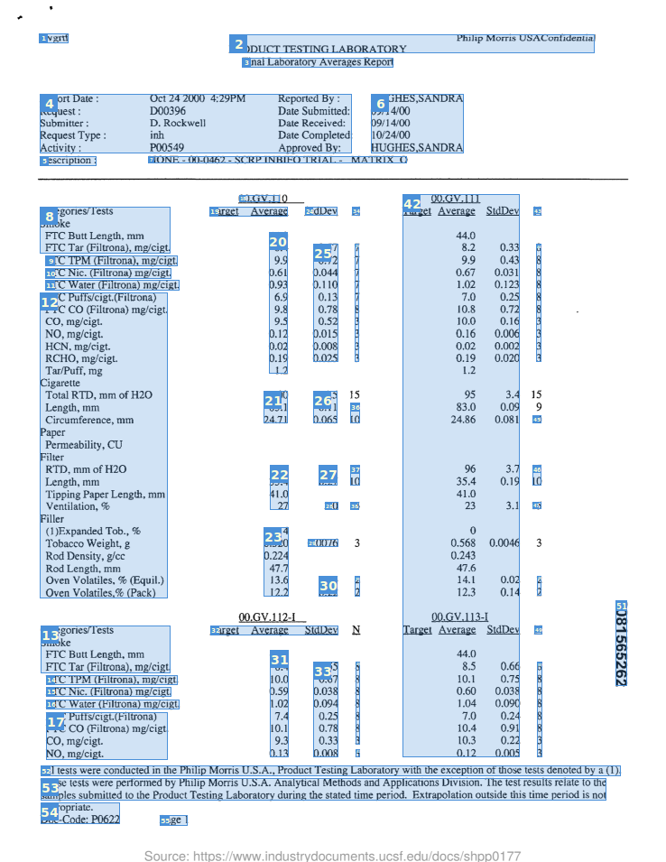

**Screen12: Test image3 for Tesseract software**

As you'll notice, Tesseract OCR recognizes the text in the well-scanned email pretty well. However, when it comes to the handwritten letter and the smartphone captured document*,* either nonsense or literally nothing is outputted.

For the output from the table image I used gImageReader, the GUI frontend mentioned above. It turns out that Tesseract outputs bounding boxes for areas of the image that contain text, but that doesn't even get close to proper table extraction. Of course you can process Tesseract's output by your own table extraction tool.

**5.2 SOFTWARE DESIGN**

**5.2.1 FRONT END**

**TKINTER**

Python offers multiple options for developing GUI (Graphical User Interface). Out of all the GUI methods, tkinter is the most commonly used method. It is a standard Python interface to the Tk GUI toolkit shipped with Python. Python with tkinter is the fastest and easiest way to create the GUI applications. Creating a GUI using tkinter is an easy task.

**To create a tkinter app:**

1. Importing the module – tkinter
2. Create the main window (container)
3. Add any number of widgets to the main window
4. Apply the event Trigger on the widgets.

Importing tkinter is same as importing any other module in the Python code. Note that the name of the module in Python 2.x is ‘Tkinter’ and in Python 3.x it is ‘tkinter’.

import tkinter

tkinter also offers access to the geometric configuration of the widgets which can organize the widgets in the parent windows. There are mainly three geometry manager classes class.

1. **pack() method:**It organizes the widgets in blocks before placing in the parent widget.
2. **grid() method:**It organizes the widgets in grid (table-like structure) before placing in the parent widget.
3. **place() method:**It organizes the widgets by placing them on specific positions directed by the programmer.

**5.2.2 BACK END**

**PYTHON**

**Python** is a high-level, interpreted, interactive and object-oriented scripting language. Python is designed to be highly readable. It uses English keywords frequently where as other languages use punctuation, and it has fewer syntactical constructions than other languages.

Python was developed by Guido van Rossum in the late eighties and early nineties at the National Research Institute for Mathematics and Computer Science in the Netherlands.

Python is derived from many other languages, including ABC, Modula-3, C, C++, Algol-68, SmallTalk, and Unix shell and other scripting languages.

Python is copyrighted. Like Perl, Python source code is now available under the GNU General Public License (GPL).

Python is now maintained by a core development team at the institute, although Guido van Rossum still holds a vital role in directing its progress.

**5.3 SAMPLE CODE**

The Back-end code has been rendered with the html Front-end pages with the help of Flask. The below code demonstrates the working of our project work.

**BACK-END CODE:**

**Code for Text Recognition in Image:**

**from imutils.object_detection import non_max_suppression**

**import numpy as np**

**import time**

**import cv2**

**import pytesseract**

**import tkinter as tk**

**From tkinter import \***

**From PIL import ImageTk, Image**

**from tkinter import filedialog**

**import os**

**#root.mainloop()**

**net = cv2.dnn.readNet("frozen_east_text_detection.pb")**

**def createnotepad():**

**filename = filedialog.askopenfilename(title='Open Notepad')**

**f=str(filename)**

**lis=f.split("/")**

**print(lis)**

**#from tkinter import \***

**# Python code to create a file**

**file = open(filename,'a')**

**return file**

**def text_detector(image):**

**orig = image**

**(H, W) = image. shape[:2]**

**(newW, newH) = (320, 320)**

**rW = W / float(newW)**

**rH = H / float(newH)**

**image = cv2.resize(image, (newW, newH))**

**(H, W) = image. Shape[:2]**

**layerNames = [**

**"feature_fusion/Conv_7/Sigmoid",**

**"feature_fusion/concat_3"]**

**blob = cv2.dnn.blobFromImage (image, 1.0, (W, H),**

**(123.68, 116.78, 103.94), swapRB=True, crop=False)**

**net.setInput(blob)**

**(scores, geometry) = net.forward(layerNames)**

**(numRows, numCols) = scores.shape[2:4]**

**rects = []**

**confidences = []**

**print("hi")**

**file=createnotepad()**

**for y in range(0, numRows):**

**scoresData = scores[0, 0, y]**

**xData0 = geometry[0, 0, y]**

**xData1 = geometry[0, 1, y]**

**xData2 = geometry[0, 2, y]**

**xData3 = geometry[0, 3, y]**

**anglesData = geometry[0, 4, y]**

**# loop over the number of columns**

**for x in range(0, numCols):**

**# if our score does not have sufficient probability, ignore it**

**if scoresData[x] < 0.5:**

**continue**

**# compute the offset factor as our resulting feature maps will**

**# be 4x smaller than the input image**

**(offsetX, offsetY) = (x * 4.0, y * 4.0)**

**# extract the rotation angle for the prediction and then**

**# compute the sin and cosine**

**angle = anglesData[x]**

**cos = np.cos(angle)**

**sin = np.sin(angle)**

**# use the geometry volume to derive the width and height of**

**# the bounding box**

**h = xData0[x] + xData2[x]**

**w = xData1[x] + xData3[x]**

**# compute both the starting and ending (x, y)-coordinates for**

**# the text prediction bounding box**

**endX = int(offsetX + (cos * xData1[x]) + (sin * xData2[x]))**

**endY = int(offsetY - (sin * xData1[x]) + (cos * xData2[x]))**

**startX = int(endX - w)**

**startY = int(endY - h)**

**# add the bounding box coordinates and probability score to**

**# our respective lists**

**rects.append((startX, startY, endX, endY))**

**confidences.append(scoresData[x])**

**boxes = non_max_suppression(np.array(rects), probs=confidences)**

**for (startX, startY, endX, endY) in boxes:**

**startX = int(startX * rW)**

**startY = int(startY * rH)**

**endX = int(endX * rW)**

**endY = int(endY * rH)**

**boundary = 2**

**text = orig[startY-boundary:endY+boundary, startX - boundary:endX + boundary]**

**text = cv2.cvtColor(text.astype(np.uint8), cv2.COLOR_BGR2GRAY)**

**textRecongized = pytesseract.image_to_string(text)**

**s=""**

**for i in textRecongized:**

**if(i.isalnum()):**

**s+=i**

**cv2.rectangle(orig, (startX, startY), (endX, endY), (0, 255, 0), 3)**

**orig = cv2.putText(orig, s, (endX,endY+5), cv2.FONT_HERSHEY_SIMPLEX, 1, (0,0,255), 2, cv2.LINE_AA)**

**print(s)**

**file.write("\n")**

**file.write(s)**

**file.close()**

**return orig**

**def main_method():**

**#image2 = img**

**image2 = cv2.imread(x)**

**array = [image2]**

**for i in range(0,1):**

**for img1 in array:**

**image0 = cv2.resize(img1, (640,320), interpolation = cv2.INTER_CUBIC)**

**Orig = cv2.resize(img1, (640,320), interpolation = cv2.INTER_LINEAR)**

**#cv2.imshow("test",image2)**

**textDetected = text_detector(image0)**

**#cv2.imshow("Orig Image",orig)**

**cv2.imshow("Text Detection", textDetected)**

**time.sleep(2)**

**k = cv2.waitKey(30)**

**If k == 27:**

**break**

**Root = Tk()**

**bg = PhotoImage(file = "bg_image.png")**

**# Show image using label**

**label1 = Label( root, image = bg)**

**label1.place(x = 0, y = 0)**

**root.title("Text Detection and Recognition")**

**root. geometry("8000x750+300+150")**

**root.resizable(width=True, height=True)**

**#l1=tk.Label(root,text="Text Detection and Recognition",font=("Algerian",20))**

**w = tk.Label(root, text="Text Detection and Recognition", font=("Algerian",40,'bold'), fg = "brown", bg = "yellow", pady=10, padx=10)**

**#w.config(anchor=CENTER)**

**#w.pack()**

**w.pack()**

**v = StringVar()**

**v.set("Text \n Text")**

**def openfn():**

**filename = filedialog.askopenfilename(title='Select Input Image')**

**return filename**

**def open_img():**

**global x**

**global img**

**x = openfn()**

**img = Image.open(x)**

**img = img.resize((400,400), Image.ANTIALIAS)**

**img = ImageTk.PhotoImage(img)**

**panel = Label(root, image=img, justify=LEFT)**

**panel.image = img**

**panel.place(x=550,y=200)**

**def video_file():**

**os.system('python video_detectionfn.py')**

**btn = Button(root, text='open image',font = ("Helvetica", 15), fg = "blue", bg = "orange", command=open_img).place(x=525,y=100)**

**btn = Button(root, text='Select_Notepad_RecognizeText',font = ("Helvetica", 15), fg = "blue2", bg = "greenyellow", command=main_method).place(x=715,y=100)**

**btn = Button(root, text='Video_file',font = ("Helvetica", 15), fg = "blue2", bg = "VioletRed1", command=video_file).place(x=1100,y=100)**

**cv2.destroyAllWindows()**

**root.mainloop()**

**Code for Text Recognition in Video:**

**import numpy as np**

**from imutils.object_detection import non_max_suppression**

**import time**

**import cv2**

**import pytesseract**

**from tkinter import filedialog**

**global fg**

**net = cv2.dnn.readNet("frozen_east_text_detection.pb")**

**def createnotepad():**

**filename = filedialog.askopenfilename(title='Open Notepad')**

**f=str(filename)**

**lis=f.split("/")**

**print(lis)**

**# Python code to create a file**

**file = open(filename,'a')**

**return file**

**def openfn():**

**global vpath**

**filename = filedialog.askopenfilename(title='Select Video InputFile')**

**vpath=filename**

**return filename**

**font_scale = 1.5**

**font = cv2.FONT_HERSHEY_PLAIN**

**f=openfn()**

**cap = cv2.VideoCapture(vpath)**

**#cap = cv2.VideoCapture(1)**

**if not cap.isOpened():**

**cap = cv2.VideoCapture(0)**

**if not cap.isOpened():**

**raise IOError("cannot open video")**

**cntr =0**

**fg=createnotepad()**

**print("fg",fg)**

**fg.write("Inside notepad")**

**while True:**

**ret,frame = cap.read()**

**img1=frame**

**cntr= cntr+1;**

**if((cntr%20)==0):**

**image0 = cv2.resize(img1, (960,640), interpolation = cv2.INTER_CUBIC)**

**orig = cv2.resize(img1, (640,320), interpolation = cv2.INTER_LINEAR)**

**#cv2.imshow("test",image2)**

**textDetected = text_detector(image0)**

**#cv2.imshow("Orig Image",orig)**

**cv2.imshow("Text Detection", textDetected)**

**time.sleep (2)**

**k = cv2.waitKey(30)**

**if k == 27:**

**break**

**if cv2.waitKey(2) & 0xFF == ord('q'):**

**break**

**fg.close()**

**cap. release( )**

**cv2.destroyAllWindows( )**

**5.4 OUTPUT SCREENS**

Our project website is developed using flask and html. These pages have been rendered to generate an user - interactive pages which take dynamic input that is, input from the user, process the output based on our algorithm and finally the output is displayed on the output screen.

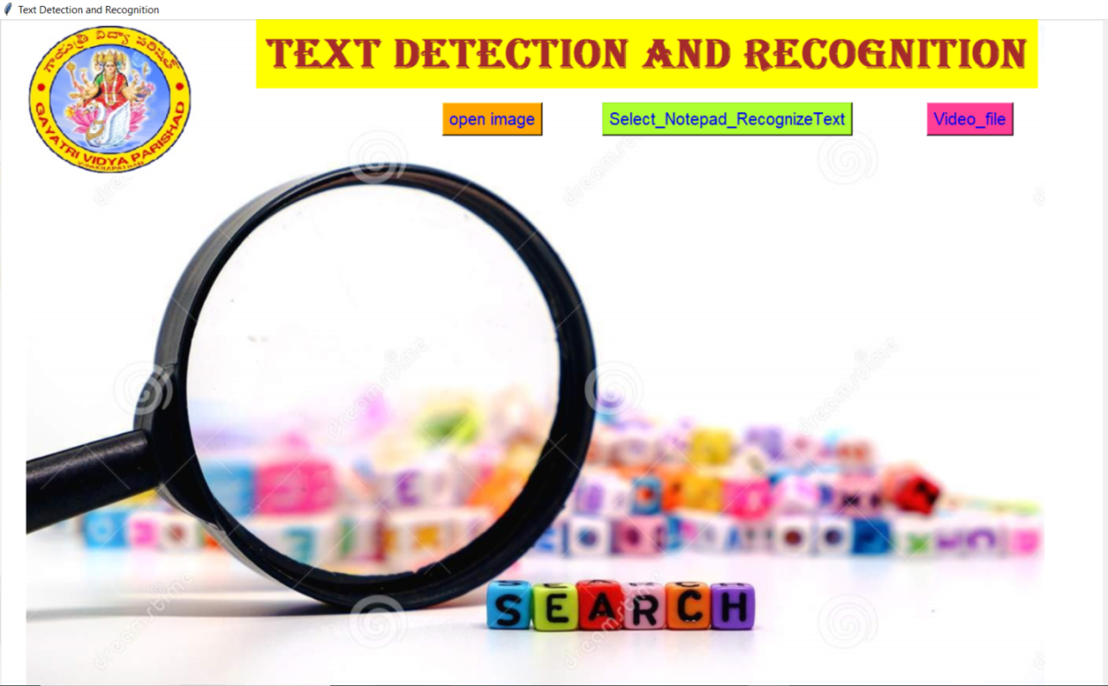

**Screen13: User Interface**

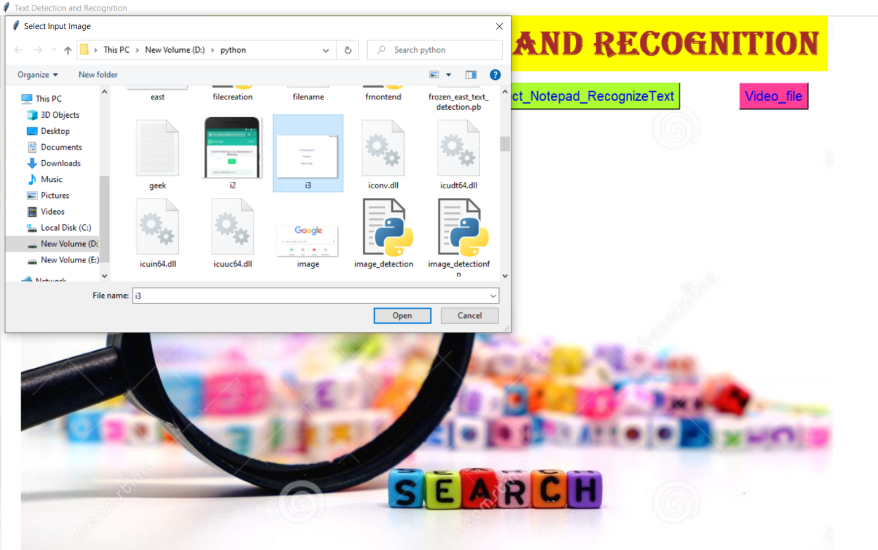

**Screen14: Taking Input Image From Device**

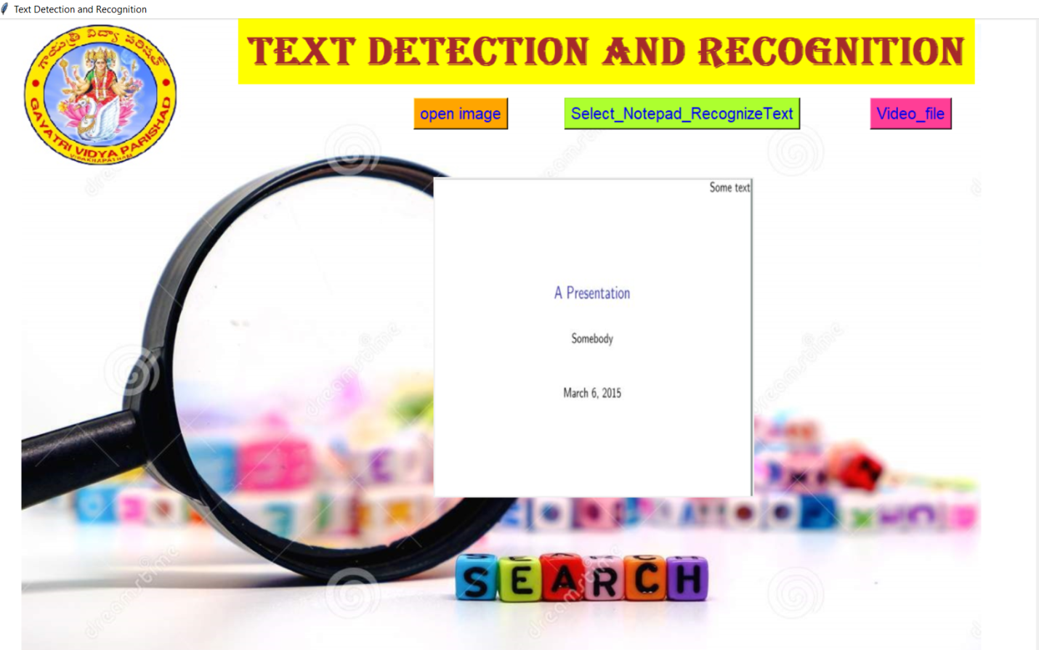

**Screen15: Input Image is displayed On User Interface**

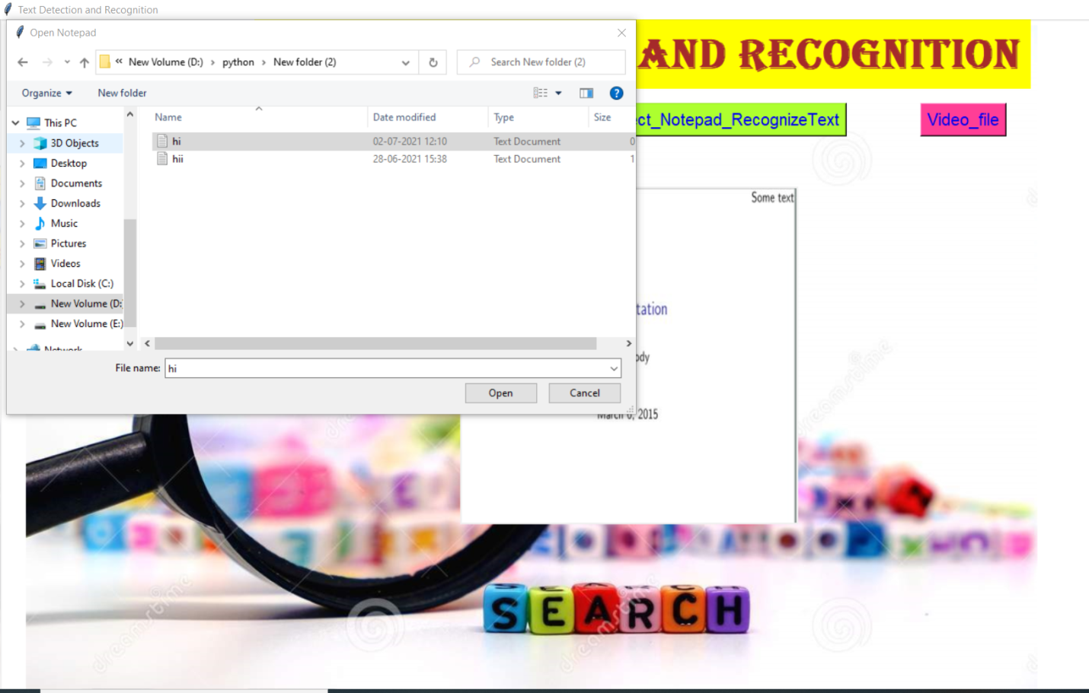

Screen16: Select Notepad to Store Recognized Text

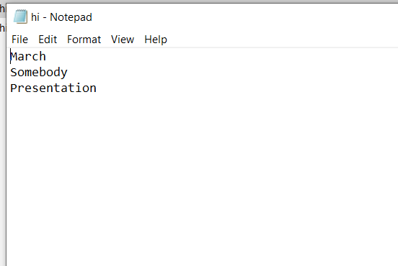

**Screen17: Text in the Input Image is Stored in the Notepad**

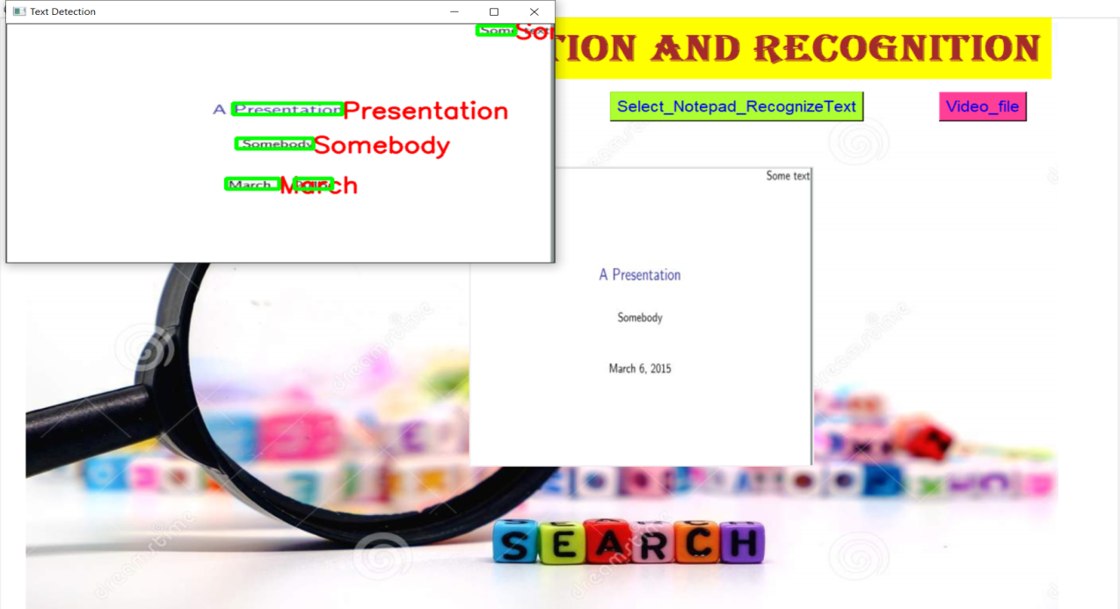

**Screen18: Output Image with Detected Text**

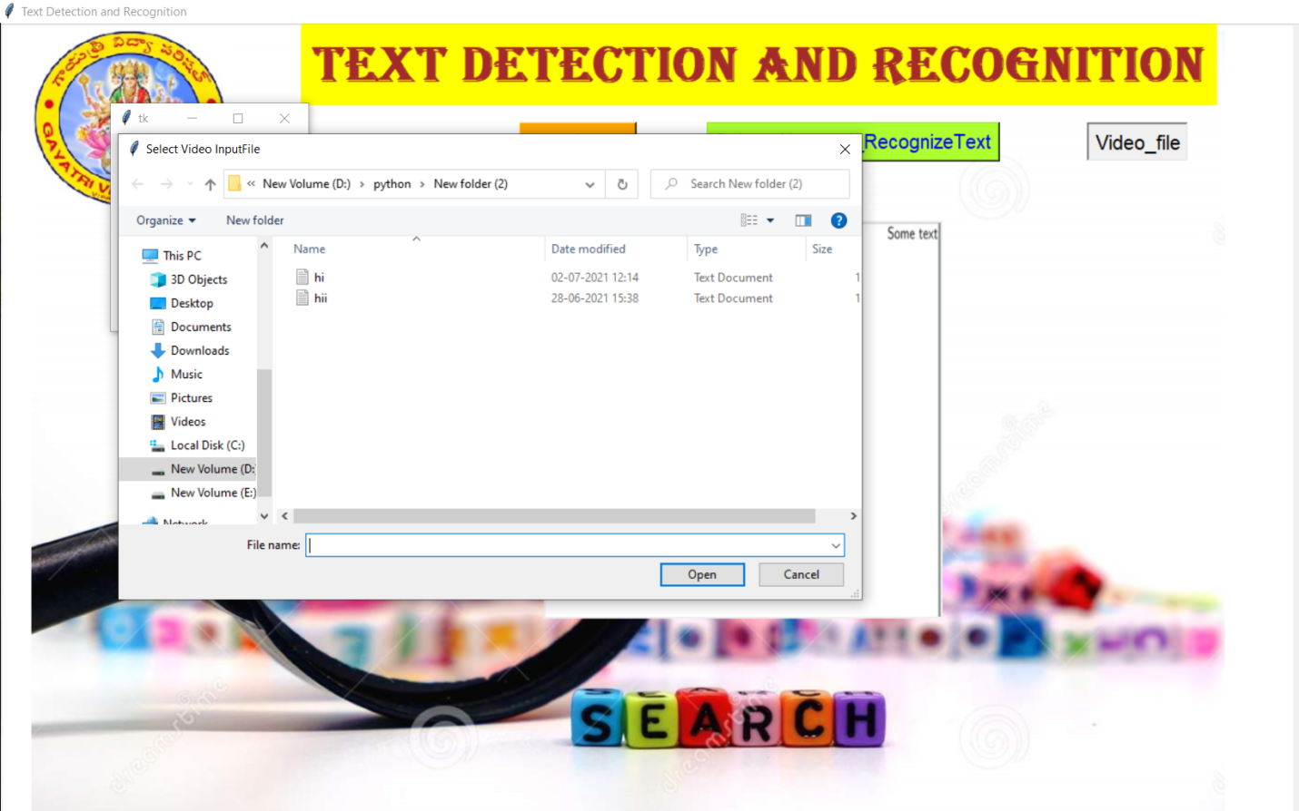

**Screen19: Taking video as a Input from Device**

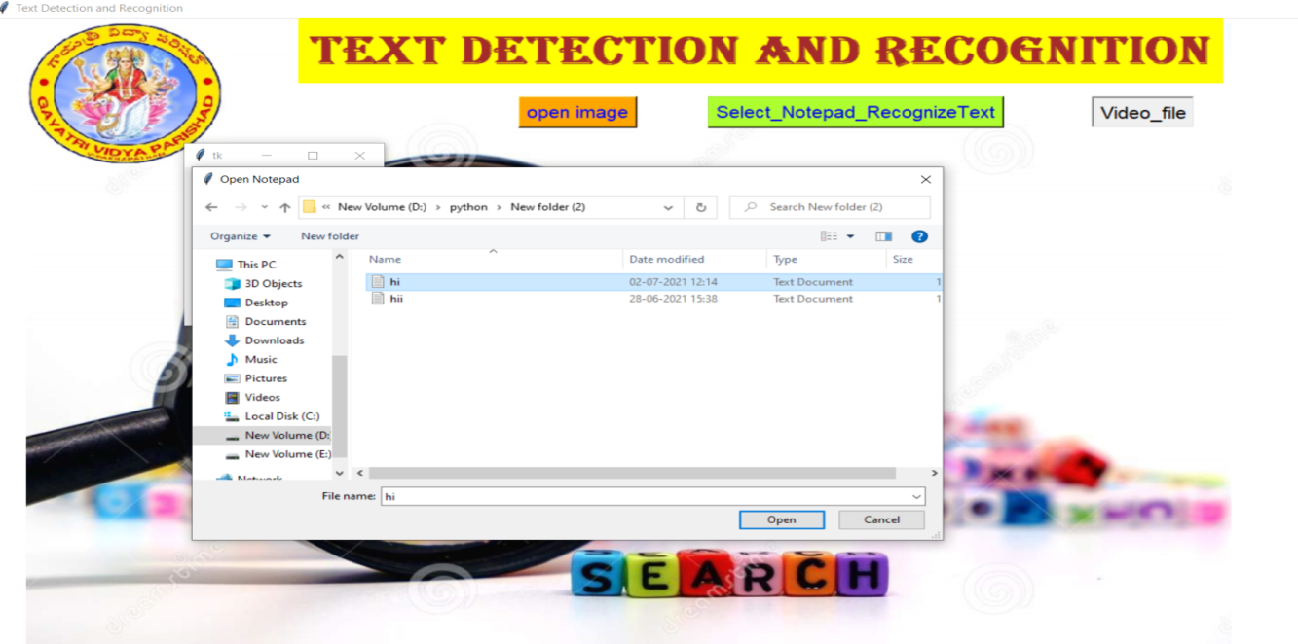

**Screen20: select Notepad to store recognized text**

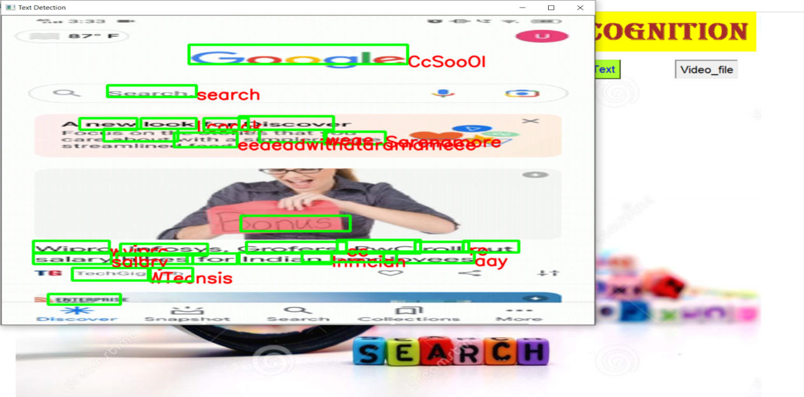

**Screen21: video is displayed as output with detected text**

##### 5.5 CONCLUSION

Hence this section deals with all the algorithms used for our implementation at the back-end that is, the entire source code along with the front-end webpage snippets. This section also contains the output of our project.

##### 6. TESTING AND VALIDATION

**6.1 INTRODUCTION**

**6.1.1 SCOPE**

A primary purpose for testing is to detect software failures so that defects may be uncovered and corrected. This is a non-trivial pursuit. Testing cannot establish that a product functions properly under all conditions but can only establish that it does not function properly under specific conditions. The scope of software testing often includes examination of code as well as execution of that code in various environments and conditions as well as examining the aspects of code: does it do what it is supposed to do and do what it needs to do. In the current culture of software development, a testing organization may be separate from the development team. There are various roles for testing team members. Information derived from software testing may be used to correct the process by which software is developed.

**6.1.2 DEFECTS AND FAILURES**

Not all software defects are caused by coding errors. One common source of expensive defects is caused by requirements gaps, e.g., unrecognized requirements that result in errors of omission by the program designer. A common source of requirements gaps is [non-](http://en.wikipedia.org/wiki/Non-functional_requirements)functional requirement[s](http://en.wikipedia.org/wiki/Non-functional_requirements) such as [testability,](http://en.wikipedia.org/wiki/Testability) [scalability,](http://en.wikipedia.org/wiki/Scalability) [maintainability,](http://en.wikipedia.org/wiki/Maintainability) [usability,](http://en.wikipedia.org/wiki/Usability) [performance,](http://en.wikipedia.org/wiki/Computer_performance) and [security.](http://en.wikipedia.org/wiki/Computer_security)

Software faults occur through the following processes. A programmer makes an [error](http://en.wikipedia.org/wiki/Human_error) (mistake), which results in a [defect](http://en.wikipedia.org/wiki/Fault_%28technology%29) (fault, bug) in the software [source code.](http://en.wikipedia.org/wiki/Source_code) If this defect is executed, in certain situations the system will produce wrong results, causing a [failure.](http://en.wikipedia.org/wiki/Failure) Not all defects will necessarily result in failures. For example, defects in dead cod[e](http://en.wikipedia.org/wiki/Dead_code) will never result in failures. A defect can turn into a failure when the environment is changed. Examples of these changes in environment include the software being run on a new [hardware](http://en.wikipedia.org/wiki/Hardware) platform, alterations in source data or interacting with different software. A single defect may result in a wide range of failure symptoms.

##### 6.1.3 COMPATIBILITY

A frequent cause of software failure is [compatibility](http://en.wikipedia.org/wiki/Computer_compatibility) with another application, a new operating syste[m,](http://en.wikipedia.org/wiki/Operating_system) or, increasingly, web browse[r](http://en.wikipedia.org/wiki/Web_browser) version. In the case of lack of backward compatibilit[y,](http://en.wikipedia.org/wiki/Backward_compatibility) this can occur because the programmers have only considered coding their programs for, or testing the software upon, "the *latest* version of" this-or-that operating system. The unintended consequence of this fact is that: their latest work might not be fully compatible with earlier mixtures of software/hardware, or it might not be fully compatible with another important operating system. In any case, these differences, whatever they might be, may have resulted in software failures, as witnessed by some significant population of computer users.

##### 6.1.4 INPUT COMBINATIONS AND PRECONDITIONS

A very fundamental problem with software testing is that testing under *all* combinations of inputs and preconditions is not feasible, even with a simple product. This means that the number of [defects](http://en.wikipedia.org/wiki/Software_bug) in a software product can be very large and defects that occur infrequently are difficult to find in testing. More significantly, [nonfunctional](http://en.wikipedia.org/wiki/Non-functional_requirements) dimensions of quality (how it is supposed to *be* versus what it is supposed to *do*) can be highly subjective; something that constitutes sufficient value to one person may be intolerable to another.

##### 6.1.5 STATIC vs. DYNAMIC TESTING

There are many approaches to software testing. [Reviews,](http://en.wikipedia.org/wiki/Code_review) [walkthroughs](http://en.wikipedia.org/wiki/Software_walkthrough) or [inspections](http://en.wikipedia.org/wiki/Software_inspection) are considered as [static testing,](http://en.wikipedia.org/wiki/Static_testing) whereas actually executing programmed code with a given set of [test cases](http://en.wikipedia.org/wiki/Test_case) is referred to as [dynamic testing.](http://en.wikipedia.org/wiki/Dynamic_testing) The former can be, omitted, whereas the latter takes place when programs begin to be used for the first time - which is normally, considered the beginning of the testing stage. This may actually begin before the program is 100% complete in order to test particular sections of code. For example, [Spread sheet](http://en.wikipedia.org/wiki/Spreadsheet) programs are, by their very nature, tested to a large extent ["](http://en.wikipedia.org/wiki/On_the_fly)on the fl[y"](http://en.wikipedia.org/wiki/On_the_fly) during the build process as the result of some calculation or text manipulation is shown interactively immediately after each formula is entered.

**6.1.6 SOFTWARE VERIFICATION AND VALIDATION**

Software testing is used in association with [verification and validation:](http://en.wikipedia.org/wiki/Verification_and_Validation_%28software%29)

**VERIFICATION**: Have we built the software right (i.e., does it match the specification?)? It is process based.

**VALIDATION:** Have we built the right software (i.e., is this what the customer wants?)? It is product based.

**6.2 DESIGN OF TEST CASES AND SCENARIOS**

|  |  |  |  |  |  |  |  |
| --- | --- | --- | --- | --- | --- | --- | --- |
| **Test case**  **ID** | **Test Type** | **Test Action** | **Expected**  **Result** | **Positive/**  **Negative** | **Actual**  **Result** | **Value Entered** | **Pass/**  **Fail** |
| 1 | WBT | Enter the image with text | Displays text in image. | Positive | Text in image is displayed. | Image1 | Pass |
| 2 | WBT | Enter the image with no text | Displays text in image. | Negative | A dialog box displays that no text is detected in image. | Image2 | Fail |
| 3 | WBT | Enter the video with text | Displays text in video. | Positive | Text in video is displayed. | Video1 | Pass |
| 4 | WBT | Enter the State | Displays text in video. | Negative | A dialog box displays that no text is detected in video. | Video2 | Fail |
| 5 | WBT | Enter the image with blur text. | Displays text in image. | Positive | Text in image is displayed. | Image3 | Pass |
| 6 | WBT | Enter the video with blur text. | Displays text in video. | Positive | Text in video is displayed. | Video3 | Pass |
| 7 | WBT | Enter the image with numerical | Displays numbers in image | Positive | Numbers in image is displayed | Image4 | Pass |
| 8 | WBT | Enter the video with numerical | Displays numbers in the video | Positive | Numbers in the video are displayed | video5 | pass |
| 9 | WBT | Enter the image with mirror text | Displays the mirror text in the image | Positive | Mirror text in the image is dispalyed | Image6 | pass |
| 10 | WBT | Enter the video with mirror text | Displays the mirror text in the video | Positive | Mirror text in the video is displayed | Video6 | pass |

**Table2: White Box Testing**

**6.3 VALIDATION TESTING**

At the culmination of the integration testing, the software was completely assembled as a package, interfacing errors have been uncovered and final series of software validation testing began. Here we test the system function in a manner that can be reasonably expected by customer, the system was tested against system requirement specification. Different unusual inputs that the user may use where assumed and the outputs were verified for such unprecedented inputs. This test is performed to validate the software. In this the entire software will be created and will test all the components of the software together. Validation testing ensures that the product actually meets the client’s needs.

**TESTING OBJECTIVES:**

* Testing is a process of executing a program with the intent of finding an error.
* A good test case is one that has a high probability of finding an as-yet-undiscovered error.
* A successful test is that uncovers an as-yet-undiscovered error.

**TEST LEVELS**: The test strategy describes the test level to be performed. There are primarily three levels of testing.

* Unit Testing
* Integration Testing
* System Testing.

In most software development organizations, the developers are responsible for unit testing. Individual testers or test teams are responsible for integration and system testing.

**6.3.1 UNIT TESTING:**

Unit testing is done on individual modules as they are completed and become executable. It is confined only to the designer’s requirements. Each module can be tested using the following two strategies.

* + - 1. **BLACK BOX TESTING:**

In this strategy some test cases are generated as input conditions that fully execute all functional requirements for the program. In this testing only the output is checked for correctness. The logical flow of the data is not checked. This testing has been uses to find errors in the following categories:

* Incorrect or mining functions
* Interface errors
* Errors in data structure or external database access
* Performance errors
  + - 1. **WHITE BOX TESTING:**

In this test cases are generated on the logic of each module by drawing flow graphs of that module and logical decisions are tested on all the cases.

**6.3.2 INTEGRATION TESTING**

Integration tests are designed to test integrated software components to determine if they actually run as one program. Testing is event driven and is more concerned with the basic outcome of screens or fields. Integration tests demonstrate that although the components were individually satisfaction, as shown by successfully unit testing, the combination of components is correct and consistent. Integration testing is specifically aimed at exposing the problems that arise from the combination of components.

* + 1. **SYSTEM TESTING**

System testing ensures that the entire integrated software system meets requirements. It tests a configuration to ensure known and predictable results. An example of system testing is the configuration-oriented system integration test. System testing is based on process descriptions and flows, emphasizing pre-driven process links and integration point.

**CONCLUSION**

Hence, this section consists of the positive and negative test cases based on white box testing as all the all of them are designed based on the input given by the user.

**7. CONCLUSION**

Text, as one of the most influential inventions of humanity, has played an important role in human life, so far from ancient times. The rich and precise information embodied in text is very useful in a wide range of vision-based applications, therefore text detection and recognition in natural scenes have become important and active research topics in computer vision and document analysis. Especially in recent years, the community has seen a surge of research efforts and substantial progresses in these fields, though a variety of challenges (e.g. noise, blur, distortion, occlusion and variation) still remain.

In this project, We have used a scene text detector that directly produces word or line level predictions from full images with a single neural network. By incorporating proper loss functions, the detector can predict either rotated rectangles or quadrangles for text regions, depending on specific applications. The experiments on standard benchmarks confirm that the proposed algorithm substantially outperforms previous methods in terms of both accuracy and efficiency. Possible directions for future research include: adapting the geometry formulation to allow direct detection of curved text, integrating the detector with a text recognizer, extending the idea to general object detection.

**8. REFRENCES**

[1] Xinyu Zhou, Cong Yao, He Wen, Yuzhi Wang, Shuchang Zhou, Weiran He, and Jiajun Liang, “EAST: An Efficient and Accurate Scene Text Detector”, Megvii Technology Inc., Beijing, China, 10-july-2017.

[2] [Shangbang Long](https://link.springer.com/article/10.1007/s11263-020-01369-0#auth-Shangbang-Long), [Xin He](https://link.springer.com/article/10.1007/s11263-020-01369-0#auth-Xin-He) and [Cong Yao](https://link.springer.com/article/10.1007/s11263-020-01369-0#auth-Cong-Yao), “Scene Text Detection and Recognition: The Deep Learning Era”, [International Journal of Computer Vision](https://link.springer.com/journal/11263) volume 129, pages161–184 (2021), [Published: 27 August 2020](https://link.springer.com/article/10.1007/s11263-020-01369-0#article-info).

# [3] [Qixiang Ye](https://ieeexplore.ieee.org/author/37416976100), [David Doermann](https://ieeexplore.ieee.org/author/37271030100), “Text Detection and Recognition in Imagery: A Survey”, [IEEE Transactions on Pattern Analysis and Machine Intelligence](https://ieeexplore.ieee.org/xpl/RecentIssue.jsp?punumber=34), Volume: 37, [Issue: 7](https://ieeexplore.ieee.org/xpl/tocresult.jsp?isnumber=7116666), July 1 2015, 03 November 2014, **INSPEC**:****15250532.

[4] Chirag Patel, Atul Patel, Dharmendra Patel, “Optical character Recognition by Open Source OCR Tool Tesseract”, International Journal of Computer Applications (0975 – 8887) Volume 55– No.10, October 2012.

[5] Riku Anegawa , Masayoshi Aritsugi , “ Text Detection on Books Using CNN Trained with Another Domain Data ”, 2019 IEEE Intl Conf on Dependable, Autonomic and Secure Computing, 5-8 Aug. 2019.

[6] Jan Hosang, Rodrigo Benenson, Bernt Schiele, “Learning Non-Maximum Suppression”, Proceedings of the IEEE Conference on Computer Vision and Pattern Recognition (CVPR), 2017, pp. 4507-4515.

# [7] [A. Neubeck](https://ieeexplore.ieee.org/author/37281866500), [L. Van Gool](https://ieeexplore.ieee.org/author/37277167600), “Efficient Non-Maximum Suppression” In [18th International Conference on Pattern Recognition (ICPR'06)](https://ieeexplore.ieee.org/xpl/conhome/11159/proceeding), **INSPEC Accession Number:**9210072, 18 September 2006.